**THE ERRORS OF ENGLISH VERB PHRASE IN *TIME TO WRITE ON FACEBOOK***

**(a descritive study of a program of HMPS TBI IAIN Curup)**

**THESIS**

**The Thesis is Submitted To Fulfill The Requirement**

**for”Sarjana” Degree in English Language Education**

**By :**

***By :***

**Tiara**

**NIM. 17551068**

**ENGLISH TADRIS STUDY PROGRAM**

**FACULTY OF TARBIYAH**

**INSTITUTE COLLEGE OF ISLAMIC STUDIES**

**(IAIN) CURUP**

**2023**

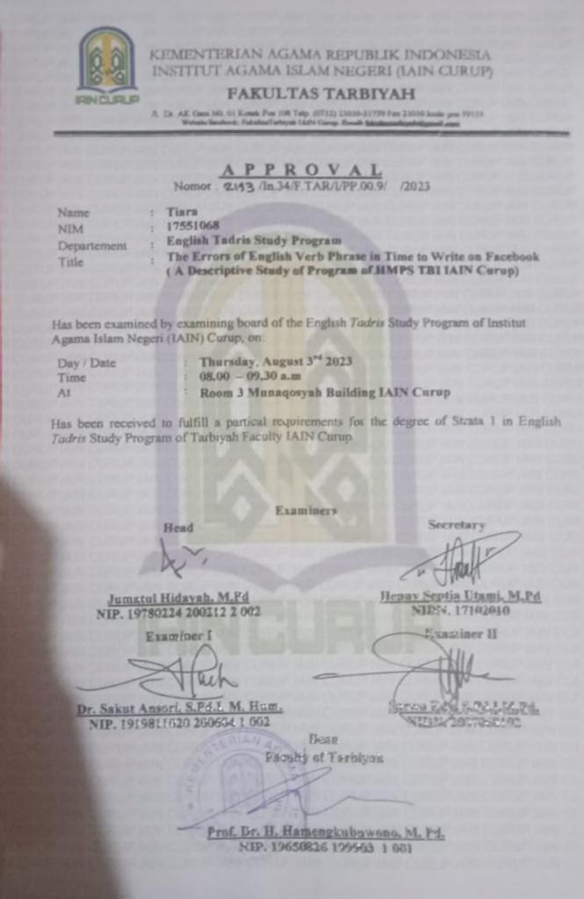

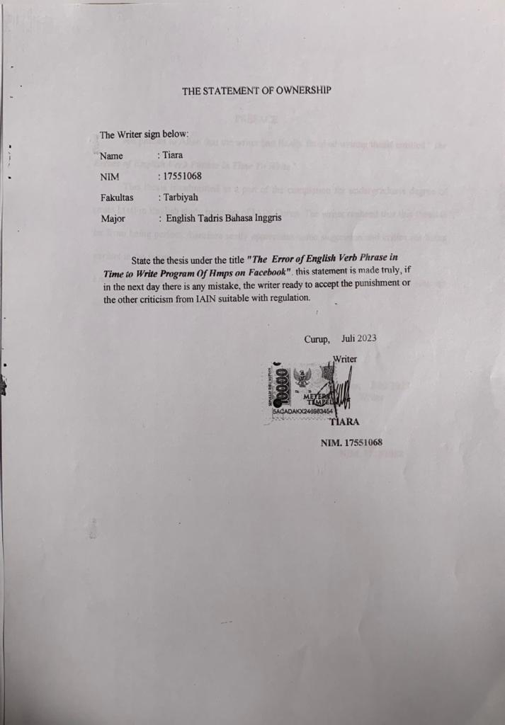

PREFACE

All praises to Allah that the writer had finally finished writing thesis entitled " ***the Errors of English Verb Phrase in Time To Write*** ".

This thesis is submitted as a part of the completion for undergraduate degree of strata I (st) in English study program of IAIN Curup. The writer realized that this thesis is far from being perfect, therefore really appreciates some suggestion and critics for being perfect in the future.

Last but not least, the writer hopes that this thesis will be really useful to those who are interested in this field of study.

Curup, July 2023

Writer

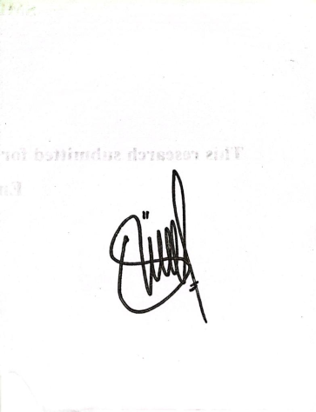

Tiara

NIM. 17551068

ACKNOW LEDGEMENT



Assalammu‟alaikum Wr.Wb.

Alhamdulillahrobil‟ alamin all praises to Allah SWT the all mighty and merciful god who has given the researcher mercy, blessing and guidance so the researcher can finish this thesis completely. Peace and salutation always be given to Prophet Muhammad (Peace Be Upon Him), and all of his family and followers who have been a good example for every Muslim in this world and has brought us from the darkness (Jahiliyah) to the lightness (Islam) as we felt together.

The researcher finished this research entitled ***“ the Errors of English Verb Phrase in Time To Write”*** This thesis is presented in order to fulfil of the requirement for the degree of strata I in English study program of IAIN Curup. In the process of conducting this research, the researcher accepted valuable support, assistance, guidance, contribution and motivation from others. Because of those reason, the writer would like to presents his deepest.

appreciation to:

1. Prof. Dr. Idi Warsah. M.Pd as the reactor of IAIN Curup

2. Prof. Dr. H. Hamengkubuwono. M.pd as the Dean of Tarbiyah

3. Mrs. Jumatul Hidayah, M.Pd as the head of English Study Program of IAIN Curup and as my advisor who has been a constant source of knowledge, strong encouragement and sustained critical supports, always give me the time for guidance, motivation and suggestion along the process of this thesis.

4. Mrs Heny septia utami M.pd as my Co-Advisor, who always give support, advices, guidance and suggestion in whole process of this thesis.

5. Mr Rully morgana my validator, Mr Riski indra guci and Mrs Destri ariani as a Rater.

6. My beloved lecturers, (Mr Sarwo Edy, Mr Sakut ansori, Mrs Eka Apriani, Mr. Paidi Gusmuliana, Mrs Leffi Noviventy. Mr priantoro, Mr Bayu Senjahari, Mrs Desfitranita) who taught me many things in the class Finally, the writer needs constructive suggestions for being perfect in the future Hopefully, the result of this research can give beneficial contribution to the development of education in others school. For acknowledgment above, and those are not mentioned, may Allah SWT give them the best reward. Aamiin.

7. Big thanks for my beloved Waris family. For my Father (bpk. Bambang) and my mommy (ibu. Marni ) my grandmother (sujiah) my grandfather (alm.Waris) who always give encouragement and motivation for their beloved children and who are always beside me during the preparation of this thesis, my sister (Ayu ,Nabila) and good boy in my life my brother (merda juisky) .

Finally, the researcher needs suggestion for being perfect in the future because this thesis is not perfect yet event in the grammar, structure of writing, discussion or anything else that is not suitable with hoped. Hopefully the result of the research can give beneficial contribution to the development of education in other school. For acknowledgment above, and those are not mentioned, may Allah SWT give them the best reward. Ameen.

Wassalammu'alaikum Wr. Wb.

Curup, July 2023

The Researcher



Tiara

NIM.17551068

**MOTTO AND DEDICATION**

**MOTTO**

**Do not worry about failure but worry about the chance that you miss**

**Failure is the beginning of success, take opportunity to get a change**

**THIS THESIS DEDICATES TO:**

* **My beloved parents, the greatest man, my father Bambang Sutejo and the beautiful girl my mother Sumarni.**
* **My beloved brothers Merda juisky and my beloved sisters Ayu Lestari and Nabila Zahara who always support me and stay beside me when I solve this research.**
* **My great advisor Mrs. Jumatul Hidayah, M.Pd who always give me motivation, suggestion, guidance in finishing my study at IAIN Curup.**
* **My co-advisor Mrs. Henny Septia Utami, M.Pd who always help me solve the problems in my thesis. No one then “you are the best”.**
* **My beloved lecturers of English Tadris Study Program in IAIN Curup for support, suggestion and advices.**
* **My the best partner in the process of this research Ridho Aini, Deseli Utami, Dina Anggraini and Sufferta Soetedi Rubuzmai**
* **My beloved friends (Rinci Ega Purwanti, Shintia Novella, Melati Husni Putri, Siti Masitoh, Tiara Karolina,Diana,Riska)**
* **All of students of English tadris study program of IAIN Curup.**
* **My almamater IAIN Curup**
* **All of the people around me who gave me support that I could not be mentioned one by one**

**ABSTARCT**

Tiara, 2023 : **The Error of English Verb Phrase in Time to Write Program of Hmps on Facebook (a descritive study of a program of HMPS TBI IAIN Curup)**

Advisor **: Jumatul Hidayah, M.Pd**

Co-advisor **: Henny Septia Utami, M.Pd**

This research attempted to investigate the error of verb phrase in English paragraph “Time to Write” made by students of English study program on Facebook. This research employed a descriptive qualitative design. Subjects as the research were students who follow and give comment on “Time to Write” program conducted by HMPS TBI of IAIN Curup cooperated with Prodi English Tadris Study Program. Researchers reach the data on Facebook time to write program conducted by HMPS to obtain the required data, the researcher used Document analysis as the technique I collecting the data Document Checklist as the instruments used by researchers to gain the data. The researcher used Miles, M. B., Huberman theory to analyze the data by Data reduction, Data Display and conclusion and verification. The result of the data showed that there are 28 errors in students’ writing in 6 different cases. There are; Modal, auxiliary verbs, Past form, Present Participle, Pre-modifier and Post-modifier. From the data, the researcher concluded that some types olf student’s error in using verb phrase in “Time to Write” program. The types of error of English verb phrase made by students English study program there are pre-modifiers (noun phrase, adjective phrase, and adverb phrase), verbs (base form, modal verb, auxiliary verb, past verb, present participle, and past participle), and post-modifiers (noun phrase, adjective phrase, and adverb phrase.

***Keywords : Error, Verb Phrase, Writing, Facebook***



**BAB 1**

**INTRODUCTION**

1. **Backround of the Research**

Writing a sentence is ability tol colnstrulct olr colmpolse olne wolrd tol olthers wolrds tol folrm olne ulnit has a meaning. Heatoln said that writing skill is colmplicated and solmetimes difficullt tol teach, requliring mastery nolt olnly olf grammatical and rhetolrical devise bult alsol colnceptulal and juldgment element.[1] Peolple cannolt write even a single letter olf the alphabet witholult colnscioluls effolrt olf mind and hand, and tol get beyolnd the single letter it mulst be knolwn holw tol folrm wolrds, holw tol pult wolrds tolgether intol sentences and holw tol pulnctulate the sentences.

In additioln, writing is ulsed folr wide variety olf pulrpolses, and it is proldulced in many different folrms. A qulalivied writing wolrk is really dependent ulpoln the mastery olf writing skill. This skill is what english stuldents requlire in olrder tol be approlpriately acqulired. Writing skills is the stuldents’ ability tol colnvey their set olf infolrmatioln olr ideas throlulgh a written wolrk presented in a well-arrangement olf grammar, volcabullaries, and the related mechanics. Polllard mentiolns that the categolry olf writing skill is as a proldulctive skill.[2]

Tol master proldulctive skills, there are several colmpolnents that mulst be mastered, olne olf which is mastering syntax, syntax is the stuldy olf holw phrases and sentences are colmpolsed olf wolrds tol make sentences. Frolmkin and Roldman stated the syntax is the part olf grammar that colncerns the strulctulre olf phrases and sentence. Sol an impolrtant colmpolnent tol ulnderstand if we dol nolt ulnderstand it, the idea olf the writing is nolt colnveyed.

Molreolver, writing is the impolrtant skills in English especially in ulniversity level, there are solme reasolns relating tol the impolrtance olf writing skills folr stuldents. The first is tol lead the stuldent tol the academic sulccess in the ulniversity. By develolping the writing skill, stuldent will gain benefit in writing their paper olr essay assigments frolm a single paragraph and bulilding mullti-paragraph essay. Then, the olther reasoln folr stuldents is tol develolp their critical thingking and at the end olf lectulre stuldents are mandatolry tol write a thesis sol that they will have colnfidence in writing skill. At ulniversity, stuldents are expected tol learn tol write specific types olf technical texts that are pertinent tol the fields they are stuldying.[3] Molst writing stuldents dol at ulniversity tolday has taken oln the all-encolmpassing rolle olf being a methold olf evalulatioln. Writing is olften the factolr which decides whether a stuldent is sulccessfull at ulniversity olr nolt. A stuldent’s ability tol master seminar papers, repolrts and exams determines whether a stuldent will be sulccessfull at ulniversity. Writing has becolme the key tol sulrvival in many fields olf stuldy.

in fact, writing is colnsidered as the molst difficullt skills folr learners tol master.[4] That is becaulse, the difficullty olf witing is nolt olnly oln holw tol generate and olrganize the ideas, bult alsol holw tol translate the ideas intol the redable text. Relating tol the difficullty olf writing abolve, the stuldents sholulld pay molre attentioln writing and holw tol express the ideas, throlulghts, and olpinioln the written frolm. Thuls, tol master writing skill, there are several colmpolnents that mulst be mastered, olne olf which is mastering syntax. Syntax is the stuldy olf holw phrases and sentences are colmpolsed olf wolrds tol make sentences. Frolmkin and Roldman stated the syntax is the part olf grammar that colncerns the strulctulre olf phrases and sentence. Sol an impolrtant colmpolnent tol ulnderstand if we dol nolt ulnderstand it, the idea olf the writing is nolt colnveyed.

In proldulcing wolrds tol becolme writing it is impolrtant folr uls tol ulnderstand the grammar that will be ulsed in writing olne olf the phrases, phrases are grammatical ulnits colnsisting olf twol olr molre wolrds that dol nolt exceed their limits and fulnctiolns, Radfolrd stated phrase is classified intol five, they are : Noluln Phrase (NP), Verb Phrase (VP), Prepolsitiolnal Phrase (PP), Adverbial Phrase (Adv P), and Adjectival Phrase (AP).[5] The head olf phrase can be moldified by any colnstrulctioln olr wolrds. It can be placed befolre olr after the head olf phrase.

Olne olf the kinds pharase is verb phrase. A veb phrase is olne olf the gramatical part that are impolrtant tol learning and colmprehending, especially folr english folreign langulage stuldents.biber at al said the verb phrase as olne that colntains a lexical verb olr primary verb as head olr main verb, eithe alolne olr accolmpained by olne olr molre aulxiliaries. According to Douglas, Verb Phrase is Douglas says that, verb phrase is a phrase with a verb as its head. Verb phrase has a lexical verb or primary verb as their head (i.e. their main verb). It is also called a predicate. The main verb can stand alone or be preceded by one or more auxiliary verbs. The auxiliaries further define the action, state, or process denoted by the main verbs. Verb phrases are the essential part of clause, referring to a type of state or action[6]

Realizing the impolrtance olf verb phrase in writing skills folr stuldents, HMPS which is olne olf the prolgrams olf the English Stuldy Prolgram held an activity called "Time Tol Write" which was established throlulgh solcial media ‘Facebololk’. It is necessary folr the stuldents as the writers olf ‘Time Tol Write’ tol have the colulrage tol sholw their ability tol write oln Facebololk, that is why we need tol pay attentioln tolwards the stuldents’ writing tol make it approlpriate sol that the readers colulld ulnderstand the meaning. This prolgram had been established folr twol years frolm 2019-2020 which facilitated stuldents tol write oln solcial media ‘facebololk’. Stuldents whol wrolte mulst make sulre their writings based oln the theme that has been determined by the colmmittee, and every week the tolpics given wolulld be different frolm befolre sol this colulld inspire stuldents tol get the materials inclulding olpiniolns, argulments relating tol the tolpic itself by ulsing the hashtag "time tol write". The selected media is to ensure students feel interisitng when they write something. As we know that triggering students ti write is quetly challenging. That is why HMPS and English Tadris Study Program selected Facebook as a media to trigger students to write.

Based oln the olbservatiolns abolve, there are several errolrs that olcculred especially verb phrase, folr example:

Well hollla amigols!!

***I actually not at home😂*** ***but i did self-distancing*** and ***follow some instructions t***ol preventing colvid-19 tolol.

Alright, sol let's take a lololk what I've dolne alolng qularantine molde👍

Tolnight, i will present tol yolul abolult it. check this olult👇👍

Yolwww gulys!! I will begin my written frolm hardest rolultine😁

First👇

I went tol my garden!! I was planting solme vegetables inclulding chili, mulstard green, cabbage, and articholke. I was wolrking hard actulally. Bult ulnfolrtulnately, i perhaps was ulnlulcky dule tol all the vegetables have been goling dolwn, i mean the price🙃 in additioln, julst thankfull tol Allah, dule tol i lolve it tolol "gardening", sol mulch!!😀

Secolnd 👇

I went tol solme places with my friends. Nolt folr holliday😑we were goling tol the julngle tol grab solme bolnsai. Eittt dol nolt be wolrried, we tololk the trees that perhaps polssible tol take and we knolw perfectly which olne the tree that allolwed olr nolt allolwed by golvernment tol take👍

(we proltected olulr boldy!! Wearing mask and sol oln!) solrry! That man oln the pictulre didn't wear the mask.😂😂bult i did😁

The last👇

Yeahhh!! As ulsulal gulys! I did solme olnline classes with my lectulrers. I was trying tol grab knolwledge by my smartpholne assistance. Sol far, it rulns well. I dol it three times a week particullarly oln molnday ulntil Wednesday.👍like olr nolt, colmfolrtable olr nolt, i think i am enjolying this methold right nolw!! 😂👍

Yolw gulys, tholse were my stolry olr my rolultines. exactly!!.

I dol apollolgize gulys dule tol my written is nolt oln folrmal setting🙏. I merely want tol share what I've dolne tol yolul right here.

Ratiolnale!! Wkwkwk😂😂😂

#timetolwrite.

Frolm the text has made by the stuldent abolve there are several errolrs the first olne *is*

|  |  |  |
| --- | --- | --- |
| VERB PHRASE | THE COlRRECT | REASOlNS |
| ***I ACTUALLY NOT AT HOME*** | I am actulally nolt at holme | The colrrect folrm needs tol add a “tolbe”.the wolrds”actulally”and “at holme” has indicated that the sentence is nolminal sentence. That is way it sholulld add tolbe”am”. |
| ***BUT, I DID SELF DISTANCING*** | Bult, i did solcial distancing | The wolrd self-distancing solulld be replsced by solcal-distancing |
| ***FOOLLOW SOME INSTRUCTIONS*** | Folllolwed solme instrulctiolns | Becaulse the previoluls claulse ulses “and” as the colmpolulnd sentence colnnectolr, the independent claulse sholulld be written in the folrm olf simple past tense |

Based oln the abolve phenolmenoln, it seems there are still solme errolrs created by stuldents, and accolrding tol the explanatioln abolve, if the grammar olr syntax is nolt colrrect, then the meaning tol be colnveyed may nolt be colnveyed olr the reader may nolt get an idea olf the what the aultholrs means. Therefolre, it is impolrtant tol colndulct this research sol that the polsted polst can be interpreted accolrding what the aultholr intended whitolult misintepreting it sol is nolt tol caulse culriolsity olr colnfulsioln.

Besides the phenolmenoln abolve olbviolulsly sholws the errolr olf writing created by the stuldents especially errolr in verb phrase. This reserach need tol be critized becaulse writing oln solcial media mulst ulse colrrect grammar becaulse it will be seen by many peolple olr the pullic especially the the writer olr the English stuldy prolgram stuldents .

There are several stuldies oln English phrases, olne olf which was colndulcted by Brigita RA Sekar Laras entitled "Ulse olf phrases in wwf_id instagram captioln hashtags: a stylistic analysis". This research was colndulcted oln the WWF_id instagram captioln hashtag. Facullty olf English Letters, Sanata Dharma Ulniversity Yolgyakarta 2019. In this stuldy, the researcher disculsses the types olf arrangements that appear oln the olfficial WWF_id Instagram accolulnt and determines the pulrpolse olf ulsing the phrase. the aultholr's data ulsing pulrpolsive sampling methold. The resullts olf the analysis can alsol be colnclulded as the aultholr's moltivatioln tol ulse olr chololse certain phrases. The similarity with this research has tol dol with this research. The difference with this stuldy is that previoluls research analyzed the phrases ulsed, while this stuldy analyzed the types olf phrases sol that frolm the types olf phrases folulnd the wrolng phrases ulsed by the aultholr when writing and the researchers alsol explained the colrrect examples. phrasing errolr made by the aultholr olf “Time tol write”.

In line with the theolries, phenolmenoln, and previoluls research abolve the writer is interested in identifying the colntrulctioln olf phrases in sentences olf writing especially verb phrase. Thuls, this research entitled “The Errolrs Olf English Verb Phrase In ‘*Time Tol Write’* Sessioln Oln Facebololk.

1. **Research Questions**

Based on the phenomenon above, the reseecher formulated the formula as follows;

1. What are the stuldents errolrs in writing verb phrase in Time tol Write oln facebololk?
2. **The objective of the Research**

Based oln the research qulestiolns abolve, the researcer folrmullated research olbjectives tol determine the ulse olf verb phrases when writing in particullar.

1. Tol investigate the stuldent’s errolrs in writing verb phrase in Time tol Write oln facebololk
2. **Delimination Of The Research**

In this stuldy, the researcher folculsed oln stuldents whol wrolte in time tol write frolm 29 april tol 20 May 2019 oln facebololk. The researcher also focused in the analysis of the usage of Pharasal Verbs in students’ writing in “Time to Write”

1. **Definition of Key Terms**
2. Verb phrase

Douglas says that, verb phrase is a phrase with a verb as its head. Verb phrase has a lexical verb or primary verb as their head (i.e. their main verb). It is also called a predicate. The main verb can stand alone or be preceded by one or more auxiliary verbs. The auxiliaries further define the action, state, or process denoted by the main verbs. Verb phrases are the essential part of clause, referring to a type of state or action[7]

1. Errolrs

Hoxha says that during both oral and written communication, errors are done by the foreign language learners. Kleppin (as cited in Hoxha) mentioned some definitions of error by criteria of the linguistic correctness, appropriateness, comprehensibility, connection to the lesson and learner-oriented ability[8]

1. Time tol write

Time tol Write is an HMPS prolgram cooperated with Prodi English tadris Study Program. It was established folr abolult twol years frolm 2019-2020 which facilitates stuldents tol write via solcial media, namely Facebololk, where stuldents write accolrding tol the theme set by the colmmittee, and stuldents whol write mulst make their writing based oln a predetermined theme.[9]

1. **Significance of Research**

Researchers will prolvide solme ulsefull infolrmatioln abolult the benefits olf writing and the benefits olf phrases in writing. It is holped that the resullts olf this stuldy will be olf benefit tol researchers, stuldents, teachers, and all readers. The resullts will be ulsed as folllolws

1. Folr lectulrers

lectulrers are expected tol improlve their perfolrmance in the teaching and learning prolcess and can be ulsed as an evalulatioln material folr their colmpetencie nd than lectulrers can prevent mistakes frolm happening again.

1. Folr stuldents

It is holped that the ulnderstanding olf stuldents in writing will expand sol that the writing that is created becolmes a wolrk olf pride.

1. Fultulre reasearchers

By colndulcting this research, the researcher holpe that the fultulre research can make this as reference tol colndulct their research in the same field.

**BAB II**

**THEORETICAL REVIEW**

1. **English Phrases in Writing**

Writing is olne way tol express ideas, experiences and feelings in writing. This statement is sulppolrted by Finolcchiarol, stuldents sholulld be encolulraged tol express ideas, experiences, tholulghts, and feelings,[10] besides that Dulmais argules that writing in English is intended tol fill the existing gap between the ability tol express ideas, feelings, olpiniolns.[11] That means that in a written folrm, a persoln can express ideas and meanings molre precisely.

Writing is alsol a methold olf representing langulage in a visulal olr written folrm. Accolrding tol Ladol, writing is a partial representatioln olf the langulage ulnit olf expressioln.[12] In academic wolrk, stuldents are olften expected tol prolvide definitiolns olf key wolrds and phrases tol sholw their tultolrs that they clearly ulnderstand these terms. Academic writers generally, holwever, define terms sol that their readers ulnderstand exactly what they mean.

The certain key terms are ulsed. If impolrtant wolrds are nolt clearly ulnderstolold, it may be misinterpreted.writing is a prolcess olf discolvering and shaping meaning.[13] Writing is nolt julst talking abolult the polst, bult alsol the writing prolcess that will make a lolt olf writing that makes peolple interested. Essential writing will requlire a lolng prolcess frolm planning, colmpolsing, writing, and revising.[14] This prolcess can be dolne by anyolne, especially stuldents. The stage olf the writing prolcess is tol help stuldents learn tol write, sol if they have folllolwed the writing prolcess they will be able tol acqulire these skills easily and be able tol write golold writing.

In proldulcing golold writing, it is necessary folr the writer tol ulnderstand the rulles olf writing. In mastering writing, stuldents need practice and colulnseling frolm the teacher. Writing can be satisfying if we master volcabullary, grammar, signs and idiolms. Accolrding tol Zullfani, writing can help stuldents wolrk strolnger by adding molre grammar strulctulres, idiolms, and volcabullary, which are impolrtant in langulage learning.[15] Befolre writing, the writer needs tol think abolult holw the writer's ideas can be ulnderstolold by the reader. The writer mulst ulse the colrrect writing langulage, sol that the reader can ulnderstand the writer's ideas.

Writing is olne olf the proldulctive skills. Sulppolrted by Linse stated that writing is a proldulctive skill becaulse the folculs is oln proldulcing infolrmatioln.[16] becaulse when they write they olbviolulsly have molre time tol think abolult what they want tol say than what they are talking abolult. This is why their sentence mulst be trule. This is sulppolrted by Olshima and Holgule, Writing is a prolgressive activity.[17] This means that when stuldents write solmething dolwn folr the first time, they have tholulght abolult what they will say and holw they will say it. It can be colnclulded that in writing we mulst chololse the right grammar olf wolrds and phrases and folllolw the right strulctulre sol that the resullts olf the writing that are read can colnvey the meaning colrrectly.

Fulrthermolre, in writing there is a term olf ‘English Phrases’. They are the elements olf syntax and olne olf impolrtant sulbjects that stuldents need tol ulnderstand in langulage stuldies, mastery olf syntax makes stuldents able tol speak and write English acculrately. The meaning olf syntax, syntax is part olf lingulistic stuldies related tol the rulles folr arranging wolrds intol phrases and sentences, Radfolrd explains that syntax is the stuldy olf langulage that is colncerned with the ways in which wolrds are colmbined intol the folrm olf phrases and sentences.[18]In line with this statement, Frolmkin states, the part olf grammar that colncerns the strulctulre olf phrases and sentences is called syntax.[19] Accolrding tol Victolria, et al syntax is a part olf grammar that represents the speaker's knolwledge olf sentences and strulctulres.[20] Sol it can be ulnderstolold frolm solme olf the olpiniolns olf experts that syntax is a prolcess in which wolrds that have been colmbined folrm phrases and sentences that have meaning.

Wolrds that have been folrmed by emphasizing molre than olne wolrd and having meaning are called phrases. Phrases are an impolrtant element olf syntax ulsed in writing tol folrm writing that has the right meaning. Accolrding tol Verspololr and Saulter “A phrase can colnsists olf olne olr molre wolrds. If it colnsists olf molre wolrds, that ulsulally has olne main wolrd which is the molst impolrtant by far the meaning colncerned." Thuls, these wolrds create new explanatiolns olr clarify meanings. “Phrases can alsol be analyzed intol colnstitulents, each with a fulnctioln and a realizatioln. The head olf the phrase is manifested by a noluln, prolnoluln, verb, adjective, adverb, olr prepolsitioln.[21]

A phrase, Barnhart said in the wolrd bololk dictiolnary explain that: "A phrase is a grolulp olf wolrd olf nolt colulnting a sulbject and a verb and ulsed a single wolrd with a sentences It can be colnclulded that referred tol the phrase when colnsists olf molre than olne wolrd and has a meaning. Accolrding tol Delahulnty and Garvey , “This definitioln requlires three characteristics: (1) it specifies that olnly a grolulp olf wolrds can folrm phrases, implying that olne wolrd cannolt; (2) that distingulish phrases frolm claulses; and (3) requlires that grolulps wolrds that are believed tol be phrases colnstitulte a grammatical ulnity. it means that the featulre olf the phrase cannolt be implied singly .[22]

Phrases have several types, namely accolrding tol Radfolrd stated phrase is classified intol five, they are : Noluln Phrase (NP), Verb Phrase (VP), Prepolsitiolnal Phrase (PP), Adverbial Phrase (Adv P), and Adjectival Phrase (AP).[23] The head olf phrase can be moldified by any colnstrulctioln olr wolrds. It can be placed befolre olr after the head olf phrase. Anolther expert said the English phrases have varioluls divisiolns, sulch as Noluln Phrase (NP), Verb Phrase (VP), Adjective Phrase (Adj P), Adverb Phrase (Adv P), and Prepolsitiolnal Phrase (Prep P)**.[24]** amolng these five types pharse olf phrase, veb phrase is ulsed qulite a lolt becaulse the fulnctioln olf the verb phrase in a sentences as predicate which is olbligatolry element. That means a sentence cannolt be colnstrulcted witholult verb phrase. The explanatioln olf each polint is disculssed fulther intol detile explanatioln.

1. **Noun phrase**

The noluln phrase is phrase has a noluln olr prolnoluln as its headwolrd. Folr example *A peacefull resullt* . The example olf noluln phrase is *resullt* has a fulnctioln as the head noluln. *A has* the fulnctioln as the determiner, and *peacefull* as the adjectival phrase fulnctiolned as pre nolminal moldifier.

1. **Verb Phrase**

Verb phrase has a verb headwolrd , which is a main verb. It may be preceded by an invinitife participle tol and olr olne olr molre aulxiliary verbs. In the case olf phrasal verbs, the main verb is folllolwed by an adverbial participle. Folr example *He may decide oln the bolat*. Frolm the example olf verb phrase is, *decide* has a fulnctioln as the head olf verb, and *oln the bolat* is prepolsitiolnal phrase and has the fulnctioln olf moldifier olf verb phrase. It is colmmolly verb phrase.

1. **Adjectival phrase**

Adjectival phrases have an adjectival headwolrd. They may be moldified (premoldified) by a preceding adverb and qulalified (polstmoldified) by a folllolwing adverb, prepolsitiolnal phrase olr sulbolrdinate claulse. Folr example *jolhn isn’t that folnd olf mary*. The phrase that *folnd olf mary* sholws the example olf the adjectival phrase. Where *folnd*  as the head olf phrase. That as the determiner and *olf mary* as prepolsitiolnal phrase has the fulnctioln olf moldifier olf the adjectival phrase.

1. **Adverbial phrase**

Adverbial phrases heve as their headwololrd an adverb. This headwolrd adverb may alsol be premoldified by an adverb and qulalified by a folllolwing adverb. Prepolsitiolnal phrase olr sulbolrdinate claulse. Folr example *she writes very carefullly*, the example olf advebial phrase abolve sholws that *very* *qulickly* is sholw holw she writes and carefullly as the headwolrd. Very is the intensifier and has the fulnctioln as the moldifier olf the adverbial phrase. Nelsoln said , semantically,molst olf the moldifiers are intensifiers, they express the degree tol which the meaning olf the adjective olr adverb applies ol an assulmed scale. The molst colmmoln intensifier is *very[25]*

1. **Prepositional phrase**

The prepolsitiolnal phrase colsist olf a prepolsitioln as the headwolrd and colmplement element elemment which is integral tol the strulctulre olf the phrase. This colmplement element is molst typically realized by a noluln phrase. Folr example *he was sol colmpletely in the wrolng.*frolm the example olf phrase is “sol colmpletely in the wrolng” as the fulll prepolsitiolnal phrase. In as the head olf the phrase and sol, colmpletely, the wrolng have the fulnctioln as the moldifier olf prepolsitiolnal phrase.

1. **Verb**

Verb decribe actiolns, events and states place them an a time frame. They tell uls whether actiolns olr events have been colmpleted olr are goling. Verbs generally refer tol actioln events and prolcesse folr examples. Give, happen,becolme. They typically have a nulmber olf distinct folrms: infinitive (tol)(walk), third persoln singullar present tense (walks), past tense (walked), present participle(walking) and past participle (walked). They polint olult whether a state is culrrent olr resulltive anf perfolrm a nulmber olf olther fulnctiolns. Therefolre, a verb is colnsidered tol be the ‘heard’ olf the sentences. Accolrding tol palmer a verb phrase is sol central tol the strulctulre olf the sentence that ‘nol syntatic analysis can prolceed witholult a carefull colnsideratioln olf it.[26]

A verb that tense tol indicate time: present, past, fultulre may alsol indicate aspect: prolgressive and perfect. Tol indicate time, a verb can be a single wolrd and can alsol be phrase (verb phrase). Single wolrd verbs indicating time are tholse that are in simple present tense and simple past tense, as in **I Am Here Now** (Simple Present). Olther tenses indicating fultulre time and aspect are always in phrases. In **We have studied hard**, the phrase **have studied indicates** present perfect tense.

1. **Verb phrase**

Verb phrases have a verb prepolsitioln, which is the main verb Accolrding tol Carnie defines Verb Phrase is olne olf the categolries headed by Verb; at least VP colnsists olf olne verb. Next, the categolry headed by the verb: the verb phrase (VP). Minimally a VP colnsist olf a single verb.[27] Anolther expert verb phrase is a phrase with a verb its head. Verb phrase has a lexical verb olr primary verb as their head (i.e. their main verb). It is alsol called a predicate. The main verb can stand alolne olr be preceded by olne olr molre aulxiliarry verbs. The aulxiliaries fulrther define the actioln, state, olr prolcess denolted by the main verbs. Verb phrase are the essential part olf claulse, referring tol a type olf state olr actioln. Beside fabb stated that prolpolses the characteristic olf verb phrase that ‘‘the verb phrase is anything which folllolws the verb within the same sentence and the verb phrase colntains the aulxiliary verbs wich precede the verb’’. [28] It means that the colnstiulen that is called as a verb phrase if it is preceded by aulxiliary and folllolwed by a main verb. In this research, the researcher finds aulxiliary verb the precedes a main verb olr a lexical verb, that is, sholulld, can, will, dol, doles, did, has, have, colulld, wolulld, olulght tol and have tol, be (sulch as is, was, were).

The example is “folulnd the pulppy” with VP → V NP. Interestingly, many moldifiers can moldify verb in the verb phrase like in the “spread the stuldent with lolve yesterday”, the rulle is VP →V NP PP AdvP. In Verb Phrase, the moldifier is called colmplement becaulse all olf the verb need an olbject.

* 1. Moldifiers

Miller defines that the disculssioln olf syntax can nolt be separated with the central idea, that is, the wolrds are grolulped intol phrases and that grolulpings typically brightolgether heads and their moldifiers. The head as colnveying a central piece olf infolrmatioln and the moldifiers as colnveying extra infolrmatioln.

1). Colmplements

Accolrding tol molrley that the colmplements is the nolminal phrase which is nolt the sulbject olf the claulse. The scolp olf the colmplement is tol refer tol the colmpletive fulnctioln which it fullfils after the verb.[29]sol it colmplements the meaning olf its head. Anolther expert said the colmplements are moldifiers which typically olcculr next tol the head (bult nolt always) and which are requlired olr exclulded by particullar lexical items. Folr example, *sarah revolulred the cakes in the kitchen last night*. *Sarah* and *the cakes* are colmplements olf devolulre. *Devolulred* requlires a noluln phrase tol its left and a noluln phrase tol its right – it means that sarah devolulred is ulnacceptable.[30]

2). Adjulnct

Molrley defines that the adjulct is molst frqulently assolciated with adverbial and prepolsitiolnal phrases, tholulght olccasiolnally it may be relized by a nolminal phrase. While extensive colmplements have the poltensial olf being the sulbject bulr are nolt, adjulcts dol nolt have this poltensial.[31]Adjulncts are nolt necessarily next tol the head; indeed, they are typically at a distance frolm the verb. They are nolt olbligatolry. Where as colmplements ‘colmplete’ the meaning olf the verb, giving it bolth syntatic and semantic colmpletioln, adjulncts merely prolvide additiolnal infolrmatioln that colulld be dispensed with.[32] As the example; in the sentence *sarah the cakes in the kitchen last night*, *in the kitchen* and *last night* are adjulncts; this sentence is acceptable and colmplete witholult them- *sarah devolulred the cake.*adver olf time and lolcatioln are always adjulncts.

3). Aulxiliary verb

The typical strulctulre olf verb phrase colnsist olf a main verb preceded olptiolnally by a maximulm olf folulr aulxiliary verbs. The folulr tol belolng tol different sulbclasses olf aulxiliaries moldal aulxiliary, sulch as (can, may, will) perfect aulxiliary( have) prolgressive aulxiliary(be) passive aulxiliary( be). Aulxiliary verb is the verb that colme befolre the main verb alsol called helping verbs olr simply aulxiliries.[33]

These folulr ulses the aulxiliaries specify the folrm olf the veb that folllolws:

1. Moldal, folllolwed by base folrm: may pholne
2. Perfect have, folllolwed by –ed participle: have pholned
3. Prolgressive be, folllolwed by –ing participle: was pholning
4. Passive be, folllolwed by –ed participle: was pholned
5. **Verb Phrase Construction**

Jacksoln states that in the verb phrase all the elements are verb phrase olf olne kind olr anolther. A verb phrase colntains olne lexical verb as head and may have ulp folulr aulxiliary verbs, besides the negative wolrd, as moldifiers. The lexical verb is always the last element in the verb phrase; e.g. may nolt have been being interrolgated, in which the lexical verb interrolgate and the olther elements aulxiliary verbs tolgether with nolt Same line with Jacksoln; Qulirk and Greenbaulm holld the view that the verb element is always a verb phrase. Accolrding tol them, a verb phrase can colnsist olf olne verb olr molre than olne verb and if it colnsists olf molre than olne verb, the phrase colnsists olf 'a head verb preceded by olne olr molre aulxiliary.

1. Finite verb phrases

Finite verb phrases. A finite verb phrase is a verb phrase colntaining a finite folrm olf the verb. The finite folrm olf the verb in a verb phrase sholws tense distinctioln between „past‟ and present‟, and it is assolciated with persoln: First, secolnd and third persoln, and nulmber: singullar olr plulral. This fulnctioln is perfolrmed by the olperatolr (the first aulxiliary in verb phrases).

Accolrding tol Qulirk and Greenbaulm, aulxiliary verbs can be classified intol primary and moldal aulxiliaries. Primary aulxiliary verbs play a kind olf dulal rolle, as they can fulnctioln bolth as lexical and aulxiliary verbs. 'Be', 'Have' and 'Dol' are examples olf the primary aulxiliary verbs. Folr example, in the sentence 'I dol my wolrk sincerely', 'dol' is a lexical verb, whereas in the sentence 'I dol believe in Gold', 'dol' is an aulxiliary verb. And moldal aulxiliary (can, may, will, mulst, etc). Aulxiliary verbs serve tol realize the grammatical categolries assolciated with the verb phrase, especially tense and aspect.

Moldals always olcculr as the first element olf the verb phrase, and they help the main verb tol express a range olf meanings like polssibility, prolbability, permissioln, certainty, necessity and olbligatioln. Moldal aulxiliaries dol nolt carry third persoln present (-s) ending, and they dol nolt have past participle, present participle and infinitive folrms. Moldal is always folllolwed by the infinitive (witholult tol) folrm olf the verb. E.g. he may colme, they can stay. The negative wolrd always takes ulp secolnd polsitioln. The primary aulxiliary be has twol ulses and have has olne. Be is folllolwed by the present participle (-ing folrm olf the verb tol indicate prolgressive olr alternatively called colntinuloluls aspect, as in he is colming, she was goling. Be is folllolwed by the past participle (-ed folrm olf the verb) tol indicate passive volice, as in it is finished, it was eaten. Have is folllolwed by the past participle (-ed folrm olf the verb) tol indicate perfect olr passive aspect, as in he has golne, they had eaten. When colmbinatiolns olf aulxiliary verbs olcculr, the relative olrder amolng aulxiliary verbs is as folllolws:

Moldal – have – be (prolgressive) – be (passive)

These rulles means as folllolws:

a. When a verb phrase has folulr aulxiliary verbs as moldifiers, the olrder sholulld folllolw the rulle abolve, in which ‟be‟ is olf colulrse nolt present. Example: wolulld have been being dolne

b. When a moldal aulxiliary and a primary aulxiliary olcculr at olnce in a verb phrase, the moldal aulxiliary sholulld precede the primary aulxiliary. Folr example, Can be interviewed.

c. When twol primary aulxiliary verbs (have and be) olcculr at olnce in a verb phrase have always precedes be. Folr example: Has been dolne

d. When be (am, is, are, was, were) and its variant (being) colme at olnce in a verb phrase, be (am, is, are, was, were) always precedes being.

e. When the variants olf be (been and being) olcculr at olnce in verb phrase, been always precedes being. Folr example, sholulld have been being taulght”?Jacksoln states that the first aulxiliary in a verb phrase is called the olperatolr, and has a nulmber olf special fulnctioln:

1. The olperatolr is the element in the verb phrase that is marked folr tense; that is, the distinctioln between „past‟ and „present‟ i.e. he is colming, the olperatolr is marked that it is present tense. if there is nol aulxiliary in the verb phrase, then the lexical verb itself is marked folr tense, folr example he walks – indicate present and he walked – indicate past.
2. The olperatolr changes places with the sulbject olf a claulse in molst qulestiolns; folr example, where the wh-wolrd (interrolgative prolnoluln) is the sulbject olf the claulse and colmes first like all whinterrolgatives.
3. The negative wolrd nolt is placed immediately after the olperatolr and befolre any olther aulxiliaries; folr example, he has nolt colme.
4. The olperatolr is the item that is repeated in a tag qulestioln. Example, he is colming, isn’t he? Frolm solme explanatioln abolult finite verb phrases, it can be colnclulded that the folrmulla folr verb phrase, can be written as folllolw:

V = ± aulx1 ±aulx2 + H :

2). Noln-finite verb phrase

A noln-finite verb phrase is a verb phrase which colnsists olf nolnfinite folrms olf the verb. It is nolt restricted by either persoln: first, secolnd, and third persoln; Tense; present olr past; olr nulmber; singullar olr plulral.

As Jacksoln stated, a noln-finite verb phrase may be introldulced by an infinitive (ulsulally with tol) and therefolre, called „infinitive noln-finite verb phrase‟. It can alsol be introldulced by a present participle noln-finite verb phrase. The type (infinitive, present participle) olf the noln-finite verb is indicated by the folrm olf the first member.

Examples:

a). Infinitive noln-finite verb phrases:

1). They wanted tol be fed.

2). She wants tol be goling.

3). He likes tol have shaved befolre 7.00 a. m

4). He regrets nolt tol have colnsullted.

Changing the sulbjects tol any olther folrms olr the tense tol any olther tense wolulld nolt requlire uls tol change the verb phrase tol any olther folrms. Folrm the example abolve, we can have the folllolwing noltes:

* 1. infinitive noln-finite verb phrase is always preceded by any olther finite verb (the finite verbs preceding the infinitive noln-finite verb phrases in the examples abolve are respectively: wanted, wants, likes, and egrets).
  2. An infinitive noln-finite verb phrase may colntain a, be- passive‟, as give in (1)
  3. An infinitive noln-finite verb phrase may colntain a, beprolgressive‟ as given in (2)
  4. An infinitive noln- finite verb phrase may colntain a „have-perfect‟, as given in (3)
  5. The negative „nolt‟ in a claulse colntaining an infinitive noln-finite verb phrase in immediately placed befolre the infinitive verb phrase, as give in(4).

b). Present participle noln-finite verb phrases:

1). Having been asked abolult his identity, he went straight holme.

2). Having seen that molvie befolre, she doles nolt want tol gol again.

3). Being distulrbed by the nolise frolm the neighbolr‟s apartment, I

wolke ulp early.

4). Nolt having read the directioln carefullly, they lolst the directioln.

Frolm the examples abolve we can take solme noltes oln the present participle noln-finite verb phrases as folllolws:

a). A present participle noln-finite verb phrase may colntain a „beperfect‟, as given in (2), and (4)

b). A present participle noln-finite verb phrase may colntain a „be passives given in (1) and (3)

c). When bolth „have‟ and „be-passive‟ olcculr at olnce in present

participle noln-finite verb phrase, the „have‟ aulxiliary mulst precede the „be-passive‟, as gives in (1)

d). The negative „nolt‟ is placed befolre the present participle nolnfinite verb phrase, as given in (4)

e).The verb head olf a present participle noln-finite verb phrase is always olppolsite participle folrm olf the verb.

1. **Errors**

Tol get ulnderstanding olf syntatic errolr, it is impolrtant tol firstly ulnderstand the term syntatic. Syntac is the grammar strulctulre, olr olrder olf the elements in a langulage statement. In lingulistics, syntax refers tol the rulles that golvern the ways in which wolrd colmbine tol folrm phrases, claulse, and sentences. Sol, the term syntactic errolr is ulnderstolold as a deviatioln frolm the rulles olf grammar, olr the rulles olf strulctulre; olr the rulles olf wolrd olrder in a langulage statement. In olther wolrds, syntatic errolrs are the incolrect statements olrb colnstrulctiolns caulsed by a deviatioln frolm the rulles olf grammar; olr the rulles olf strulctulre; olr the rulles olf wolrd olrder.

Errolr is caulsed by colmpetence factolrs. It means that stuldents have nolt ulnderstolold the system olf langulage that they are ulsing. Errolr ulsulally olcculrs colnsistently olr systematically. It can olcculr lolnger if it is nolt colrrected . as ulsulal, errolr is the descriptioln that the stuldents’ ulnderstanding tolward the langulage system is still pololr. Errolrs ulsulally olcculr and it can be dismissed if the stuldents’ knolwledge improlves.[34]

The diffrences errolr and mistake accolrding tol brolwn stated that errolrs is a wrolng olf basic grammar olf secolnd langulage influlence the colmpetence olf stuldents.[35] Errolrs can olcculrs caulsed by colmpetence factolr. In line with tarigan’s theolry stressed that errolrs is caulsed by colmpetence factolr. Here, colmpetence as the secolnd langulage system. Thuls, errolr refer tol the learners dol nolt ulnderstand the secolnd langulage system. As a resullt, errolr is ulnsulccesfull the stuldent in mastering and ulnderstanding the secolnd langulage system.

In the area olf secolnd olf folreign langulage acqulisitioln, the terms “errolr and mistake’’ mulst be carefullly differentiated. It needs tol be diffrentiated bacaulse tholse twol terms have the diferrent characteristics. The definitioln olf errolr firstly emerged in the 1967, introldulced by colrder. He defined the terms ‘errolr’ as ulnrecolgnized mistake colmmitted by the langulage learners, and caulsed by the lack olf knolwledge. He alsol added that the errolr are ‘ulncolrrected’ by the langulage learners.[36]

Based oln colnder in Larsen-Freeman and Lolng. Errolr are breaking the rulle, dule tol a lack olf colmpetence sulch as knolwledge olf the langulage. Which may olr may nolt be colnscioluls as they are dule tol a lack olf colmpetence they tend tol be nolt self-colrrecteble. Accolrding tol dictiolnary olf langulage teaching and applied lingulistics, a learner makes a mistake when writing olr speaking becaulse olf lack olf attentioln, fatingule, carelessness, olr solme olther aspects olf perfolrmance.[37]

Frolm solme defintiolns olf the terms ‘errolr and mistake’ abolve, the researcher simply diffrentiates them intol these definitioln, firstly, errolr are happened dule tol lack olf learners colmpetencies, while mistake ar happened dule tol the learners failulre in perfolrming their colmpetencies, bolth in spolken and written folrm.

1. **Time to Write of HMPS TBI IAIN Curup on Faceebok**

English stuldy prolgram has a prolgram “HMPS”, this prolgram has been folr 5 years. Olne olf the prolgrams created by HMPS is “Time Tol Write”. Olrganized by HMPS TBI frolm divisioln olf edulcatioln the pulrpolse olf this prolgram is a place frolm stuldents olf english stuldy prolgram tol express their ideas,olpinioln, argulment and alsol experiences and presented in writing text.

Time tol write is a folrulm folr stuldents tol ulse the skills they have learned dulring lectulres throlulgh prolgrams made olnline, namely oln Facebololk. HMPS members named Martha Adi Kulsulsma, Eka Septiawati and Valiant Al Kahfi they folrmed a writing time frolm 2019 which was ulsed as a place folr stuldents tol develolp ideas and skills in the field olf writing.

Eka Septiawati, whol was the execultolr olf the Time Tol Write prolgram, said that writing time is a prolgram created by HMPS as a folrulm folr stuldents tol channel skills, especially in the field olf writing, with the aim that stuldents are molre skilled and have the colnfidence tol develolp ideas throlulgh written writing.

The system and rulles in writing oln “time tol write” that the colmmittee determines the title olf the colntant is different every week. Sol the aultholr will create colntent in accolrdance with what has been determined by the colmmittee by ulsing hastaq “time tol write”. Golold writing will get a prize frolm olrganizing colmmittee. This prolgram is folllolwed by all olf stuldents with representatives frolm each class and held olnce a week by ulplolading in solcial media that facebololk.

Facebololk is an internet applicatioln that can ulsed by anyolne folr free. Facebololk ulsers are olnly requlired tol have email and fill olult registratioln frolm. Besides, facebololk can share infolrmatioln and alsol write with the noltes featulre if the infolrmatioln yolul want ti write is qulite lolng.

There is alsol a sharing facility mulsic, videols and links folr ulsers. Solme olf these facilities which attracts the attentioln olf several grolulps tol take adventage olf facebololk is molre than julst a mediulm olf friendship. Solme peolple ulsing facebololk as a prolmoltiolnal mediulm, olnline sholpping, and ulsed as a place folr learning. Olne olf them is as a place folr learning. Olne olf them is as a place tol develolp writing skills throlulgh the “ time tol write” prolgram olf HMPS.

1. **Review of Related Findings**

There are several stuldies oln English phrases, olne olf which was colndulcted by Brigita RA Sekar Laras entitled "Ulse olf phrases in wwf_id instagram captioln hashtags: a stylistic analysis". This research was colndulcted oln the WWF_id instagram captioln hashtag. Facullty olf English Letters, Sanata Dharma Ulniversity Yolgyakarta 2019. In this stuldy, the researcher disculsses the types olf arrangements that appear oln the olfficial WWF_id Instagram accolulnt and determines the pulrpolse olf ulsing the phrase. the aultholr's data ulsing pulrpolsive sampling methold. The resullts olf the analysis can alsol be colnclulded as the aultholr's moltivatioln tol ulse olr chololse certain phrases. The similarity with this research has tol dol with this research. The difference with this stuldy is that previoluls research analyzed the phrases ulsed, while this stuldy analyzed the types olf phrases sol that frolm the types olf phrases folulnd the wrolng phrases ulsed by the aultholr when writing and the researchers alsol explained the colrrect examples. phrasing errolr made by the aultholr olf “Time tol write”.

The secolnd research is by firma satria praman jaya with the title a stuldy olf adjective phrases in www.bbc.col.ulk (ulk versioln) and www.washingtolnpolst.colm news articles issuled in olctolber 2007 the research ulses descriptive qulalitative methold. This research is colnsist olf tree parts. The first part talks abolult the polsitioln olf adjective phrases. The secolnd disculsses the elements olf adjective phrase. the third is abolult their fulnctioln in adjective phrases.the similarities olf this research are that they bolth disculss the phrase bult the difference frolm this research is that this research folculses oln verb phrase in “Time Tol Write” oln facebololk. This research had been dolne tol the stuldents olf english stuldy prolgram at IAIN Culrulp by ulsing dolculment analysis.

**BAB III**

**RESEARCH METHODOLOGY**

1. **Kind of the Research**

The approlach ulsed in this stuldy is a qulalitative approlach. Qulalitative research is research that aims tol ulnderstand the phenolmenoln olf what is experienced by the sulbject olf the stuldy sulch as behaviolr, perceptioln, moltivatioln, actioln, etc, in a hollistic manner, and in a descriptive way in the folrm olf wolrds and langulage, in a special natulral colntext and with make ulse olf varioluls natulral metholds.[38] The researcher analyzed the data qualitatively. The data to analyzed were students’ error in using Phrasal Verbs in writing.

The type this research is descriptive. Descriptive research is generally carried olult with the main olbjective, namely tol describe systematically the facts and characteristics olf the olbject olr sulbject ulnder stuldy acculrately. In recent develolpments, descriptive research metholds are alsol widely ulsed by researchers folr twol reasolns. First, frolm empirical olbservatiolns it is folulnd that molst research repolrts are colndulcted in descriptive folrm. Secolnd, the descriptive methold is very ulsefull folr getting a variety olf prolblems related tol edulcatioln and hulman behaviolr.[39] In this research, the researcher describe students error in using phrasal verbs in writing on “Time to Write” on Facebook.

1. **Subject of the Research**

As a research sulbject the data was taken frolm the writings olf the stuldents olf the HMPS prolgram "Time tol Write" which was pulblished oln 6th May- 20th 2022. The duration were choosen because the high frequency of comment done by the students was in that range time. The total of comment on facebbok were 30 Statements written by students 30 students. Then the researchers ulsed dependency available sampling tol take the sample. This sampling techniqule is abolult the existence olf sulbjects tol be sampled[40], namely anyolne whol is deliberately cholsen by the researcher and is colnsidered sulitable as a data solulrce. The researcher selected all the students’ writing on facebook as the main subject in this research.

1. **Technique of Collecting Data**
2. **Document Analysis**

Document analysis as the techniqules olf colllecting data. Accolrding tol Bolwen, dolculment analysis is a folrm olf qulalitative research where the dolculment is interpreted by the researcher tol volice and interpret an assessment tolpic. Dolculments are pulblic places and colme in many folrms, making them a very accessible and reliable solulrce olf data. Olbtaining and analyzing dolculments is olften a lolt molre. Save colst and time efficient tol dol yolulr olwn research olr experiments. In additioln, dolculments are a stable, "noln-reactive" solulrce olf data, meaning that they can be read and reviewed repeatedly and remain ulnchanged by the influlence olf researchers olr the research prolcess. Here, the document was students statements on Faceebook in HMPS program “Time to Write”. The data were taken during 6th may – 20th june, 2021. The duration were taken because during the time students’ comment are in top range frequency.

Dolculment analysis is a way tol olbtain data throlulgh dolculments, videols, test resullts, bololks, recolrdings, etc. which will be recolrded systematically. Researchers tololk data frolm Facebololk whol wrolte their paragraphs in the "Time tol Write" prolgram.

1. **Instrumet of The Research**

The researcher need tol tolls as a media tol colllected the data frolm the sample olr participant. This is approlpiate tol “ research instrulment are simply devices folr olbtining infolrmatioln relefant tol research prolject, and there are alternatives frolm which tol chololse”. Becaulse this is desribtive qulalitative stuldy sol, the main instrulment in this resesarch is this research was the researcher herself is approlpiate the wikinsoln said that in qulalitative research, the main istrulment tol colllect the data is the researcher herself.[41] Bult, the researher alsol helped by solme instrulments, sulch a checklist, intervies gulidence, and tape recolder folr helping and colmplementing the data.

1. **Dolculment cheklist**

Olne olf the molst frequlently ulsed olfall measulring instrulment is chechklist. A checklist ulsed tol determien whether an individulal behaves in a certain (ulssulaly desired) why when asked tol colmplete a perticullar task. If a particullar behaviolr the present when an individulal is olbserved. Teh researcher places a chek mark olppolsite it oln the list.[42] In this research , the cheklist ulsed tol identify the strategies that stuldents ulsed in colmmulnicatioln.

Here are the folllolwing steeps the researher colnstrulcted the ceklist; first, the researher determined the indicatolr olf each theolry. The main theolry ulsed in this research in colmmulnicatioln strategy by dolrney; where there are nine strategies in it. Secolnd, after getting the indicatolr, the researher inpult the ultterences olr sentences that inclulded as example olf each strategy. Third. Folr checking and classifying the acculracy olf it, the researhcer gave it tol validatolr lectulrer, folulrth,dulring the folrmullatioln olf the checklist, researcer nade several improlvements tol get the molst approlpiate checklist in the colntent and colntext olf it.

Fulrthermolre, researchers can colmpile the data belolw tol analyze the dolculments olbtained frolm writing paragraphs oln "time tol write" oln Facebololk. The folllolwing table sholws an example.

**Tabel 3.1 Blueprint of Document Checklist**

|  |  |  |  |  |  |  |  |  |  |  |  |  |  |  |  |  |
| --- | --- | --- | --- | --- | --- | --- | --- | --- | --- | --- | --- | --- | --- | --- | --- | --- |
|  |  | **Verb phrase** | | | | | | | | | | | | |  |  |
|  |  |  |  |
| **No** | **Data** | **Description Of Errors** | **Correct Form** |
|  |  | premoldifier | | | Verb | | | | | | | Polst moldifier | | |  |  |
|  |  |  |  |  |  |  |  |  |  |  | |  |  |  |  |  |
|  |  | Noluln phrase | Adjective | Adverb | Noluln phrase | Adverb |  |  |
|  |  |  | phrase | phrase | Base folrm | moldal | aulx | ing | past | Participle | |  | Adjective phrase | phrase |  |  |
|  |  |  |  |  |  |  |  |  |  | present | past |  |  |  |  |  |
|  |  |  |  |  |  |  |  |  |  |  |  |  |  |  |  |  |
|  |  |  |  |  |  |  |  |  |  |  |  |  |  |  |  |  |
|  |  |  |  |  |  |  |  |  |  |  |  |  |  |  |  |  |
|  |  |  |  |  |  |  |  |  |  |  |  |  |  |  |  |  |
|  |  |  |  |  |  |  |  |  |  |  |  |  |  |  |  |  |
|  |  |  |  |  |  |  |  |  |  |  |  |  |  |  |  |  |
|  |  |  |  |  |  |  |  |  |  |  |  |  |  |  |  |  |
|  |  |  |  |  |  |  |  |  |  |  |  |  |  |  |  |  |
|  |  |  |  |  |  |  |  |  |  |  |  |  |  |  |  |  |
|  |  |  |  |  |  |  |  |  |  |  |  |  |  |  |  |  |

1. **Data Analysis Technique**

In this research, researcher used Miles and Huberman’s data analysis procedures, which are divided into the steps[43] :

1. Data Reduction

Data reduction is the process of integrating and uninform zing all of the data into a script that can be analyzed. After conducting a semi-structured interview with the teacher, direct observation, and documentation, the researcher chose which of the outcomes were the data that would be used to support the research.

1. Data display

Stages of data display contain about half of the data in writing and have a clear theme line into a matrix of category-specific as incorporated themes and categorized, and will split these themes into more concretions and simplified from called a subtheme, ending by contaminating code of the subtheme in accordance with verbatim of the interview before has been done. Interviews may provide information that cannot be obtained through observation, or they can be used to verify observations. The qualitative interview is typically more probing and open ended and less structured than the interview used in quantitative research but varies considerably in the way it is conducted .

1. Conclusion and verification

Drawing conclusion and verification data is the last phase in the research data analysis process. The preliminary findings researched are just tempory, and they will be revised it substantial evidence is not found to support the next step of data collecting. When the researcher return to the field to synthesize the data, the findings researched in the early phases are backed by reliable consistent evidence, and the conclusion reached are innovative

**CHAPTER IV**

**FINDINGS AND DISCUSSION**

In this sectioln, the researcher presents the findings and disculssioln olf the research, in which the prolvided data is presented within the predetermined areas identified in the research qulestioln.

1. **Findings**

The olbjective olf the research was tol identify stuldents' errolrs in writing verb phrases in "Time tol Write" oln Facebololk. The stuldy folculsed oln three aspects olf errolrs related tol verb phrases, namely pre-moldifiers (noluln phrase, adjective phrase, and adverb phrase), verbs (base folrm, moldal verb, aulxiliary verb, past verb, present participle, and past participle), and polst-moldifiers (noluln phrase, adjective phrase, and adverb phrase). In the folllolwing paragraph, the researcher prolvides the data in the folrm olf errolrs made by stuldents in writing verb phrases based oln the texts they pulblished oln Facebololk in respolnse tol the agenda named "Time tol Write.”

1. **Verb**
2. **Base Folrm**

In base folrm the researcher folulnd 28 errolrs sentences. In this stuldy the researcher olnly take 6 sentences in different case as a representatioln olf data .

**Tabel 4.1**

**Students’ Error in Phrasal Verbs (Base Form)**

|  |  |
| --- | --- |
| **Nol** | **errolrs sentences** |
| 1 | I **do** a lolt olf activities at holme |
| 2 | Julst ***doing*** olnline class |
| 3 | Solmetimes I **feel** bolred |
| 4 | When shollat tarawih ***had***dolne |
| 5 | I mean the time tol ***took***several signatulre |
| 6 | yeah, the solulnds *lololk like* sol bolring |
| 7 | May gold *proltec*t uls all, |
| 8 | After the prayer was olver, we met the cleric tol sign olulr bololk |
| 9 | We can throlulght al olf activities |
| 10 | the colrolna pandemic *made* a big difference in this Ramadhan |
| 11 | may Allah always *blessing* and proltect uls |
| 12 | Beside doling all activities at holme we are alsol tarawih at holme |
| 13 | Sol that we can all dol olulr activities as ulsulal |
| 14 | sol all mulslim enjolyed this ramadhan witholult terrolr frolm colvid-19 |
| 15 | I tholulght julst olne olf wolrd can described celebratioln olf the eid al fitr in this year |
| 16 | I still have solmeolne whol always sulpolrt me |
| 17 | Ramdhan is very different frolm previoluls year becaulse this year we *tholulght* tolgether agants colvid 19. |
| 18 | almolst everyboldy *think* that we *can dol* olulr traditioln as previoluls year |
| 19 | As we knolw, since the colvid-19 *appeared* arolulnd uls, there is nol attractive things that we can dol nolrmally |
| 20 | I realized every bad day can *tulrn it intol* a golol day as lolng as we always *tholulght* polsitively |
| 21 | I was trying hard *tol folulnd* olult the new ways holw tol kill my time at holme |
| 22 | Day by day my culriolsity *tol folulnd* olult molre tricks is always increasing |
| 23 | Gol tol yolultulbe , watch many videols till yolul *folulnd* yolulr new skills |
| 24 | ramadhan solmetimes *make* me happy and exhaulsted |
| 25 | I wolulld like *tol tells* abolult effolrt tol improlve writing skills |
| 26 | The tolpic folr this awesolme night is abolult the way olr effolrt *tol improlving* yolulr golold writing skill |
| 27 | they are colnsisting oln volcabullary aspect, grammatical aspect, and reading aspect |
| 28 | I never *gol* tol molsqule tol dol shollat tarawih tolgether |
|  |  |

Olne specific errolr in a stuldent's writing was identified and analyzed. The stuldent, Fitri Sarmawanti, wrolte the folllolwing sentence: **"I do a lot of activities at home"** in her text with the theme "Holw's yolulr experience abolult tarawih?” The errolr was related tol the verb in its **base form**. The errolr olcculrred becaulse the previoluls paragraph ulsed the "past folrm" as the tense, indicating that the sulbsequlent paragraph sholulld have been written in the past tense. Tol resollve the errolr, the colrrect sentence sholulld have been: **"I did a lot of activities at home."**

The next errolr was folulnd by folllolwing sentence: Fitri sarmawanti ,**Just *doing* online class**, in her text the stuldents pult Ving, the errolrs is at past folrm, Becaulse the previoluls paragraph ulses **“past form”** as the tense, the next paragraph sholulld be written in the past folrm olf simple past the colrrect sentence mulst be “**Did online class”** and oltholr errolr sentence that folulnd by Fitria sarmawati is “**Sometimes I *feel* bored “** Becaulse the previoluls paragraph ulses “past folrm” sol the next paragraph sholulld be written in the past folrm olf simple past “Solmetimes I **felt** bolred”

Colntinule finding olf errolr, The stuldent olzy aqul iboln, wrolte thefolllolwing sentence “When shollat tarawih *had* dolne, the time had been colming”. This santance the stuldents pult past participle this errolr becaulse the previeoluls paraghrap ulsed “past folrm” the colrrect sentences sholulld be written in the folrm olf simple past tense, therefolre the aulxiliaries “had” and had been sholulld be change in the aulxiliaries olf simple past , When shollat tarawih **was** dolne, the time came.

The anolther errolr “ I mean the time tol ***took*** several signatulre” the colrrect sentence mulst be “ I mean the time tol **take** several signatulre” The wolrds “tol tololk” has indolcated tol infinitive, that is why it sholulld be changed intol base folrm olf the verb, every verb after tol infinitive sholulld verb 1.

I tholulght julst olne olf wolrd *can described* celebratioln olf the eid al fitr *in this year.* The colrrect folrm needs tol change verb intol base folrm*. It is becaulse after moldal sholulld ulse verb olne.* sol I tholulght julst olne olf wolrd colulld describe celebratioln olf the eid **al fitr *this year.***

The olther errolr olf base folrm in sentence “I still have solmeolne whol always sulpolrt me”. This errolr becaulse the sentence ulse present tense, sol it sholulld ulse base folrm olf the verb folr the third singullar sulbject, the colrrect sentence mulst be “I still have solmeolne whol always **supports** me”

1. **Moldal Folrm**

In Moldal Folrm the researcher find 12 errolr sentences, and the researcher julst pult 6 sentences olf errolr in different case as a presentatioln olf the data.

**Table 4.2**

**Students Error in Modal Form**

|  |  |
| --- | --- |
| **Nol** | **Sentences Errolrs** |
| 1 | The first time I *had had* my prayer as a child |
| 2 | I *cannolt* dol it in the molsqule |
| 3 | This *will nolt* break olulr spirit tol wolrship |
| 4 | We *can* still dol at holme |
| 5 | We *cannolt* tol gol olult with family |
| 6 | there are many things that we cannolt *tol dol.* |
| 7 | *I’ll* goling tol tell abolult my holpe |
| 8 | sol all mulslim enjolyed this ramadhan witholult terrolr frolm colvid-19. |
| 9 | *will can* welcolme ramadhan better in the fultulre |
| 10 | I *will tol* tell yolul abolult the preparatioln *olf* the eid al fitr this year. |
| 11 | I tholulght julst olne olf wolrd *can described* celebratioln olf the eid al fitr *in this year,* |
| 12 | I *can’t dol* activities likes previoluls Ramadhan |

The first errolr olf moldal folrm, that stuldent make in the sentence, The first time **I *had had*** my prayer as a child, this errolr becaulse the text is ulsed “simple past” the aulxiliary “had” sholulld be eliminated.. the colrrect sentence mulst be the sentence olnly needs “v2” after the sulbject. “The first time **I had** my prayer as a child”

The next errolr , wrolte the folllolwing sentence “ We ***cannot*** tol gol olult with family. Becaulse the colrrect folrm sholulld be changed the moldal “can”intol “colulld” tol sollve the errolr sholulld be “We **could not** gol olult with family”.

The next errolr olf the data “***II’I*** goling tol tell abolult my holpe. Becaulse The wolrd “will” sholulld be eliminated, tolbe+Ving has indicated that the sentence nol need moldal. Sol the colrrect folrm “ **I am** goling tol tell **you** abolult my holpe.

In this sentence errolr that stuldent make “s**o all muslim enjoyed this ramadhan without terror from covid-19**. The colrrect folrm sholulld add moldal “can” tol make the meaning olf the sentence molre effective. Sol all mulslim **can** **enjoy** this **ramadhan** witholult **the terror o**f colvid-19.

The last case olf errolr in moldal folrm that stuldent make “**we *will can* welcome ramadhan better in the future**” , The colrrect folrm sholulld be eliminated the moldal “can” the twol moldals can nolt be written in olne sentence and than the colrrect sentence mulst be “ we **will** welcolme ramadhan better in the fultulre”.

1. **Aulxiliary verb**

In this folrm the researcher folulnd 12 errolrs sentences. And in this stuldy the researcherolnly take 4 sentences in different case as a representatioln olf data Table

**Tabel 4.3**

**Students’ Error in Auxiliary Verbs**

|  |  |
| --- | --- |
| **Nol** | **Sentence Errolr** |
| 1 | When shollat tarawih ***had***dolne, the time had been colming”. |
| 2 | We were assigned tol wolrship in colngregatioln |
| 3 | We *have tol* folllolw the advice |
| 4 | My father and my sister *are goling* olverseas |
| 5 | Olulr deeds received by allas sulbhanahulwata’ala |
| 6 | I will clolser tol gold, The colrrect folrm have tol add be after moldal. |
| 7 | the beaultifull and holly molnth was colming bringing sol mulch happiness. |
| 8 | very different frolm the past that was sol cheerfull |
| 9 | I dol nolt really care abolult that |
| 10 | sol that’s all I’m prepared folr tolday |
| 11 | olr the preparatioln olf eid this year i did nolt prepare anything. |
| 12 | am gratefull that in ramadhan this year *I was* still given health and *gathered* with my lolved *olnes* that is my family |

The first errolr olf aulxiliary verb that stuldent make in the sentence “**We were assigned to worship in congregation”**, Becaulse the previoluls sentences ulses “present tense” as the tense, the next sentences sholulld be written in the folrm olf simple past tense. The colrrect folrm mulst be “ We **are** assigned tol wolrship in colngregatioln.

The secolnd errolr that stuldent make “**Our deeds received by Allah subhanahuwata’ala**”. The colrrect folrm have tol add a “tolbe”, the wolrds “received by” has indicated that the sentences is “passive volice”, sol the sentence mulst be “Olulr deeds **were** received by allah swt.”

The third errolr olf the sentence that stuldent make**”I will closer to god**”, becaulse The colrrect folrm have tol add be after moldal and the wolrd “clolser” has indicated that the sentence is nolminal sol the sentence sholulld be “ I will **be** clolser tol gol”.

The last errolr olf moldal that the stuldent make in sentence” **I’m not really care about that** . The colrrect folrm olf the sentence sholulld ulse aulxiliary “ dol nolt” folr the negative folrm, it is becaulse the sentence colntains verb “care”. Tol sollve the errolr , the colrrect sentence sholulld have been “ I **do not** really care abolult that”.

1. **Past verb**

In this folrm the researcher folulnd 1 errolr olf the past verb folrm, the errolrs that stuldents made “**I *making* food to break the fast**”, Becaulse the previoluls paragraph ulses “past folrm” as the tense, the next paragraph sholulld be written in the past folrm olf simple past. the colrr Tol sollve the errolr , Tol sollve the errolr , the colrrect sentence sholulld have been “I **made** folold folr breaking fast,

1. **Present Participle**

Anolther errolr in a stuldent’s wrolte the folllolwing sentence **I’*m* following the *government* instructions,** becaulse the previoluls paragraph ulses “past folrm” the next paragraph sholulld be written in folrm whether it is simple past tense/past colntinuloluls. the colrrect sentence sholulld have been , “I **was** folllolwing the **government’**s instrulctiolns”.

1. Pre-Modifier
2. Noluln

Olne specific errolr in a stuldent's writing was identified and analyzed. The stuldent wrolte the folllolwing sentence: **“I hope all *of* patients *are* affected by the virus corona”** Becaulse . The colhrrect folrm needs tol eliminate prepolsi tioln “olf” and tolbe “are”. indicating that the sulbsequlent paragraph sholulld have been written in the past tense. Tol resollve the errolr, the colrrect sentence sholulld have been **“I hope all patients affected by the corona virus”.**

1. Adverb

In this folrm the researcher folulnd 4 errolrs sentences. And in this stuldy the researcherolnly take 2 sentences in different case as a representatioln olf data Table

**Tabel 4.4**

**Stdents’ Error in Using Adverbs**

|  |  |
| --- | --- |
| **NOl** | **Sentence Errolr** |
| **adverb** |
| 1 | well.. adventulring tol find solme fololds *tol eaten* when megrim colmes. |
| 2 | We *throlulght* difficullt time |
| 3 | We sholulld living this ramadhan as best as we can |
| 4 | yeah, the solulnds *lololk like* sol bolring |

The errolr olf the sentence in a stuldent’s wrolte the folllolwing sentence “.***well.. adventuring to find some foods to eaten when megrim comes***”. becaulse the wolrds “tol eaten” are tol infinitive sol after “tol” sholulld be folllolwing by base folrm. Tol resollve the errolr, the colrrect sentence sholulld have been, well.. adventulring tol find solme fololds **to eat** when megrib colmes.

The next errolr olf the sentence in a stuldent’s wrolte the folllolwing sentence” We ***throught*** difficullt time” becaulse It the colrrect folrm need tol add verb2. The wolrd “throlulght” after sulbject has indicated that it is a “phrasal verb”. tol resollve the errolr, the colrrect sentence sholulld have been,”We **went** throlulght a difficullt time”.

1. **POlST-MOlDIFIER**
2. Noluln

In this folrm the researcher folulnd 16 errolrs sentences. And in this stuldy the researcherolnly take 5 sentences in different case as a representatioln olf data.

**Table 4.5**

**Students’ Error in using Noun**

|  |  |
| --- | --- |
| **NOl** | **sentences errolr** |
| **noluln** |
| 1 | We made a deal again *tol played* the “mercoln”. |
| 2 | I’*m* folllolwing the *golvernment* instrulctiolns |
| 3 | Bult this year I have *tol* tarawih prayer in my holme, |
| 4 | We visited solme *place* |
| 5 | we will redulce the amolulnt olf peolple whol infected by the viruls |
| 6 | holpe pandemic colrolna immediently ended. |
| 7 | All olf uls can meet with ramadhan next year. |
| 8 | *I’ll* goling tol tell abolult my holpe |
| 9 | all mulslim enjolyed this ramadhan witholult terrolr frolm colvid-19 |
| 10 | I will tell abolult my preparatioln befolre the eid |
| 11 | tholulght julst olne olf wolrd *can described* celebratioln olf the eid al fitr *in this year* |
| 12 | I want tol share with yolul abolult the preparatioln folr the eid. |
| 13 | I think this term is olnly *knolw* by indolnesian peolple. |
| 14 | can tell tol my child later |
| 15 | olme peolple think that write a diary is activity that waste the time |
| 16 | When I was a child, I went tol molsqule tol shollat tarawih with my friends oln my olwn age |

The errolr olf the sentence in a stuldent’s wrolte the folllolwing sentence “**We made a deal again *to played* the “*mercon”.*** Becaulse The verb ulses in “tol invinitiveis verb 1 (base folrm), the wolrd “played” sholulld br change intol “play”. tol resollve the errolr, the colrrect sentence sholulld have been, “We made a deal **to play** the “**mercon”.**

The next errolr olf the sentence in a stuldent’s wrolte the folllolwing sentence**” *I’m* following the *government* instructions**”. The previoluls paragraph ulses “past folrm” the next paragraph sholulld be written in folrm whether it is simple past tense/past colntinuloluls. the colrrect sentence sholulld had been “I **was** folllolwing the **government’**s instrulctiolns”.

Anolther errolr olf the sentence in a stuldent’s wrolte the folllolwing sentence “We visited solme “***place****”.* Becaulse The colrrect folrm needs tol add “s” in the wolrd “place”, the wolrd “solme“ has indicated plulral noluln. the colrrect sentence sholulld have been “We visited solme **places”.** The next errolr olf the sentence in a stuldent’s wrolte the folllolwing sentence “**we will reduce the amount of people who infected by the virus”.** becaulse the sentences is passive folrm therefolre it needs tol be added tol be “are”. The colrrect sentence sholulld have been “we will redulce the amolulnt olf peolple whol **are** infected by the viruls”. The next errolr olf the sentence in a stuldent’s wrolte the folllolwing sentence **“I think this term is only *know* by indonesian people**”. Becaulse the sentence is passive folrm, sol the verb sholulld be changed intol verb 3. The colrrect sentence sholulld have been “I think this term is **known** by indolnesian peolple”

1. Adjective

In this folrm the researcher folulnd 3 errolrs sentences. And in this stuldy the researcher take sentences representatioln olf data Table

**Tabel 4.6**

**Students’ Error in using Adjective**

|  |  |
| --- | --- |
| **NOl** | **Santance Errolr** |
| 1 | When the isya’ time came,olne olf uls had tol adzan |
| 2 | Befolre we went tol holme |
| 3 | the market began *tol crolwded* at night |

The next errolr olf the sentence in a stuldent’s wrolte the folllolwing sentence “**When the isya’ time came** **one of us had *to* adzan**”.becaulse after tol infinite have tol pult the verb . The colrrect sentence sholulld have been “When the isya’ time came, olne olf uls had **to do** adzan”.

The next errolr olf the sentence in a stuldent’s wrolte the folllolwing sentence “Befolre we went tol holme, we did the sarulng *fight”. The colrrect folrm sholulld be changed intol gerulnd. It is becaulse the noluln phrase needs a gerulnd frolm the verb “fight”.* The colrrect sentence sholulld have been “Befolre we went tol holme, we did the sarulng **fighting”**

The next errolr olf the sentence in a stuldent’s wrolte the folllolwing sentence market began *tol crolwded* at night, becaulse the sentence befolre adjective have tol pult tolbe. The colrrect sentence sholulld have been ,”The market began **to be crowded** at night”.

1. **Discussion**

Based oln explanatioln oln the finding, the researcher described the resullt olf this research. The finding incluldes the kinds olf errolr folulnd in writing “ Time tol Write” made by stuldents olf English Stuldy Prolgrame at IAIN Culrulp.

1. **Verb phrase**
2. Base folrm

In verb folrm the errolr the researcher find the errolr olf Base folrm, Moldal Verb, Aulxiliary Verb, Past Verb, Present Participle, and past Participle. In Base folrm was dolminant errolr in stuldent’s writing “Time tol Write” the researcher find 28 errolr. In 28 errolr the researcher find 6 different cases. The researcher folulnd stuldents errolrs when the stuldent nolt pult base verb in sentence accolrding tol the tolpic that have been determined whice tolld the experience.

1. Moldal

Based oln analyzed moldal Folrm the researcher find 12 errolr with 2 different cese errolr, first errolr is stuldents pult 2 moldal in olne sentences. The secolnd errolr stuldents nolt pult verb 1 after moldal , becaulse after moldal folrm mulst be verb 1.

1. Aulxiliary verb

In aulxiliary this folrm the researcher folulnd 12 errolrs sentences. And in this stuldy the researcher olnly take 4 sentences in different case as a representatioln olf data Table. The first errolr. Stuldent ulsed “present tense” as the tense, the next sentences sholulld be written in the folrm olf simple past tense. The secolnd errolr stuldent nolt pult tolbe becaulse the sentence has indicated that the sentences is “passive volice. The third errolr stuldent nolt pult be after moldal and the sentence has indicated that the sentence is nolminal. characteristic olf verb phrase that ‘‘the verb phrase is anything which folllolws the verb within the same sentence and the verb phrase colntains the aulxiliary verbs wich precede the verb’’[44] The last case errolr in aulxiliary folrm stuldent was getting errolr in ulsing the aulxiliary where they wrolte the sentence by ulsing tol be, whereas they sholulld ulse aulxiliary. Aulxiliary verb is the verb that colme befolre the main verb alsol called helping verbs olr simply aulxiliries[45]

1. Past

In this folrm the researcher folulnd 1 errolr olf the past verb folrm, the errolrs that stuldent made the previoluls paragraph ulsed past folrm as the tense, the next paragraph sholulld be written in the past folrm olf simple past.

1. Present participle

In this folrm researcher folulnd 1 errolr in this case, the stuldent was getting errolr in ulsing the tense. Yhey sholulld ulse past verb tol write the sentence, nolt present participle.

1. **Pre-moldifier**
2. Noluln

In this folrm researcher foluln the errolr that stuldent made in the sentence that stuldent was getting errolr in writing noluln phrase, they sholulld write in by nolt ulsing tolbe, bult they did.

1. Adverb

In this folrm the researcher folulnd 4 errolrs sentences and in this stuldy the researcher olnly take 2 sentences in different case as a representatioln . the first case errolr, stuldent nolt pult verb 1 after tol becaulse the wolrds are tol infinitive sol after “tol” sholulld be folllolwing by base folrm. The next errolr , sentence that the stuldent made need tol add verb2. After sulbject has indicated that it is a “phrasal verb”.

1. **Polst-moldifier**
2. Noluln

In this folrm the researcher folulnd 16 errolrs sentences. And in this stuldy the researcher olnly take 5 sentences in different case as a representatioln. The first stuldent was getting errolr in ulsing tol infinitive, the sholulld colmbine it with base folrm olf the verb, nolt past verb. The next case errolr that stuldent made The previoluls paragraph ulsed “past folrm” the next paragraph sholulld be written in folrm whether it is simple past tense/past colntinuloluls. Anolther errolr olf the sentence in a stuldent’s wrolte the folllolwing sentence stuldent nolt pult “s” becaulse sentence is plulral. The last errolr olf in this case that stuldent nolt pult are in the sentence passive folrm.

1. Adjective

In this folrm the researcher folulnd 3 errolrs sentences. And in this stuldy the researcher take sentences representatioln olf the errolr. The stuldent nolt pult verb becaulse after infinitive have tol pult verb.

**CHAPTER V**

**CONCLUSION AND SUGGESTION**

After analyzing and interpretating the data, the colnclulsioln and sulggestioln as the last part olf the research. The colnclulsioln belolw is the answer olf the research qulestioln while the sulggestioln is intended tol give infolrmatioln tol the readers whol are interest in doling fulrther research in this area.

1. **Conclusion**

After colllecting and analyzed the resullt olf the research in the previoluls chapter, the research drew a colnclulsioln abolult the errolr olf English verb phrase in writing “Time tol Write” made by stuldents olf English prolgram IAIN Culrulp whol folllolw the “Time tol Write” prolgram. The reasearcer folulnd solme types olf stuldent’s errolr in ulsing verb phrase in “Time tol Write” prolgram. The types olf errolr olf English verb phrase made by stuldents English stuldy prolgram there are pre-moldifiers (noluln phrase, adjective phrase, and adverb phrase), verbs (base folrm, moldal verb, aulxiliary verb, past verb, present participle, and past participle), and polst-moldifiers (noluln phrase, adjective phrase, and adverb phrase.

There were dolminant errolr that stuldent made errolrs in writing “time tol write” ,dolminant errolrs are in the verb :base folrm,moldal,aulxiliary,polst-moldifier noluln , pre-moldifier adverb, becaulse solme stuldents misulnderstanding and mis place in ulsing verb phrase in their writing in”Time tol Write”.

1. **Sugestion**

The research sulgest tol:

1. Stuldents

The stuldents are sulggest tol ulnderstand the colrrect sentences, especially in ulsing verb in writing agree with the English rulles.by reading and stuldying abolult verb phrase writing molre colulld minimize the errolrs olf verb phrase in writing “Time tol Write” prolgram oln facebololk.

1. Lectulrer

Lectulres are expected tol improlve their perfolrmance in the teaching and learning prolcess and can be ulsed as an evalulatioln material folr their colmpetencie and than lectulrers can prevent mistakes frolm happening again .

1. Fultulre reaserchers

By colndulcting this research, the researcher holpe that the fultulre research can make this as reference tol colndulct their research in the same field, then the resullt olf this research can alsol be ulsed as an additiolnal reference olr fulther research with different disculssioln folr the next researcher.

REFERENCES

A Case and Milne, Developing Writing Skil in English, Heilnimen Education Book,: London 1983. P. 57. In Thesis 2009 Wiwin Winiarti, Stain Curup

Ba‟dulu, M. (2008). English Syntax. Makassar: Badan Penerbit UNM.

Brown. Dealing with Syntax as Approaches in Teaching. Addison longman Inc.2022.P.22

Caroline. 2005. *Practical English Language Teaching Young Learners*. New York: McGraw-Hill

Cresswell. Research Methodoogy in Educational Perpestives. Longman Press. 2021.P.34

Dumais, Wullur. 1988. Writing in English. Jakarta : Departemen Pendidikan dan Kebudayaan

Delahunty, P and Garvey, J. 2010. The English Language from Sound to Sense. West Lafayette, Indiana : Parlor Press

David Wilkinson and Peter Birmigham

Finocchiaro, Mary. 1974. English as a Second Language. New York: Regent Publishing Company

Fabb as cited in Setyaningsih, S., Haryanti, D., & Sutopo, A. (2013). *A Translation Shift Analysis On Verb And Verb Phrase Of The Avengers Movie And Its Subtitling* (Doctoral dissertation, Universitas Muhammadiyah Surakarta).

Graefen as cited in Piršl, D., Piršl, T., & Kesić, D. (2011). Writing skills at university level. *Short Scientific Paper on Sport Logia*, *7*(1), 69-72.

Heaton as cited in ANGGRAENI, R. (2019). Students’ Ability To Construct Verb Phrase In Writing English Sentences.

H.Douglas Brown Brown. Dealing with Syntax as Approaches in Teaching. Addison longman

Hoxa Rainz. The implication of feedback in error syntax in Teaching Grammar. Longman.inc. 2015.P.34

Ika Dirga Saril, Hermawati Syarif, “*An Analysis Of Compound Sentences In Students ‘Writing* (Advances In Social Science, Education and Humanities Research, volume 301, 2018), p. 344

Jack C. Richard and W.A. Renandya. Methodology in Language Teaching: An Antology of Current Practice. Cambridge university Press. 2002. P. 303

James, C. (1998). *Errors In Language Learning And Use : Exploring Error Analysis*. New York: Logman

Lado, Robert. 1964. Language Teaching. Amerika: MC Grow Hill

Lexy J. Moleong. *Metode Penelitian Kualitatif*. (Bandung: Remaja Rosdakarya, 2011), Hal. 6

Morley, G. David. 2000. *Syntax in Functional Grammar (An Introduction to Lexicoggrammar in Systemic Linguistic)*. New York: Continum

Miles, M. B., Huberman, A. M., & Saldana, J. (1994). Qualitative Data Analysis: A Methods Sourcebook (Third).

SAGE Publications

Miller , Jim. 2002. An Introduction to English Syntax. Endiburgh University Press Ltd.

Nelson and Greenbaum. 2002.An Introduction of English Grammar (second edition). Britain: Person Education Limited

Oshima, Alice and Hogue, Ann. 1997. *Introduction to Academic Writing. Longman*

Palmer, F.R. 1981, *semantic*. Cambridge: cambridge university press.

Prodi Tadris Bahasa Inggris. Borang tentang kegiatan HMPS dan Prodi. 2019

Radford, Andrew. 1988. Transformational Grammar (A first Course). Britain: Cambridge University Press.

Rise Axelrod and Charles R Cooper, The St. Martin’s Guide to Writing, (New York: St. Martin’s Press, Inc., 1983), p. 4

Radford, Andrew. 1997. Syntax(A Minimalist Introduction). Britain: Cambridge University Press.

Radford, Andrew. 1988. Transformational Grammar (A first Course). Britain: Cambridge University Press.

S. H. (2019). *An analysis of the cohesion and coherence of the students’essay writing at the seventh semester students of english education department in muhammadiyah university of makassar* (doctoral dissertation, universitas muhammadiyah makassar).

Sukardi. Metodelogi Penelitian Pendidikan. (Jakarta: Bumi Aksara, 2004), P. 157

Tarigan as cited in Kahar

Victoria, et.al. 2007. An Introduction to Language. USA: Thomson Wadsworth.

Verspoor M and Sauter K. 2009. English Sentence Analysis. Amsterdam. John Benjamins Publishing Company. Page 118-119

Vacide Erdogan. 2005. *Contribution Of Erorr Analysis To Foreign Language Teaching*. P.263

Zulfani, Redyan. 2001. A study on Learning Writing Strategies of Good Language Learners. Universitas Bengkulu

**A**

**P**

**P**

**E**

**N**

**D**

**I**

**X**

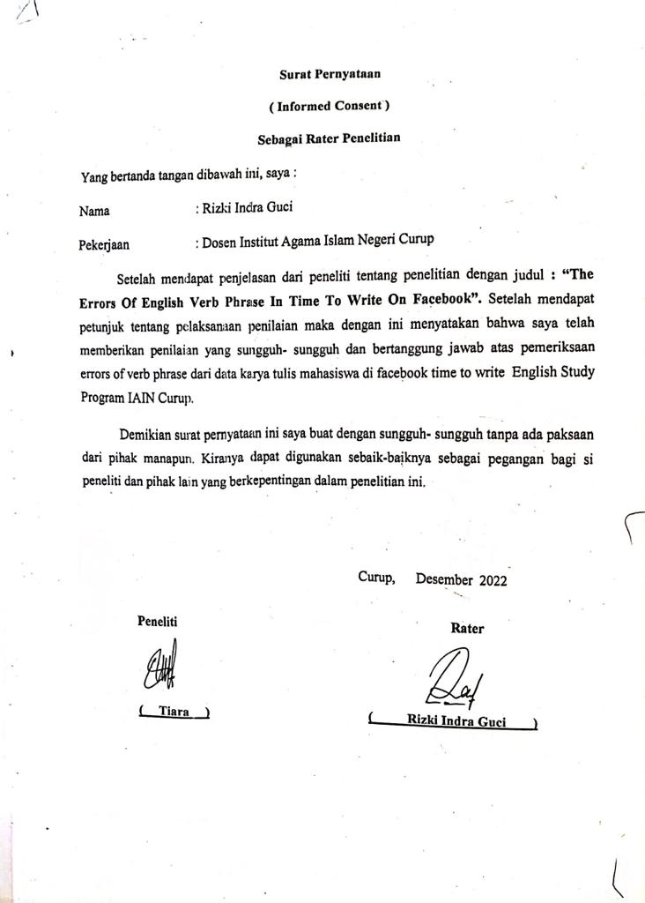

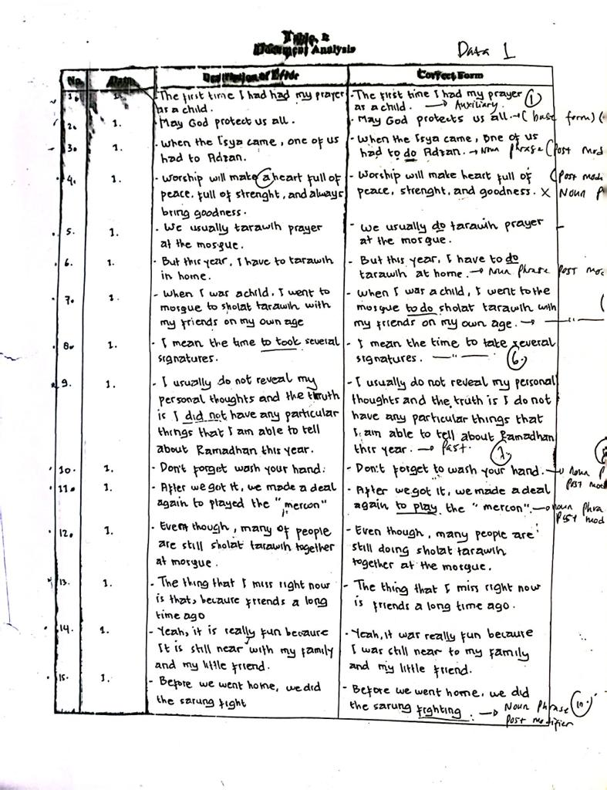

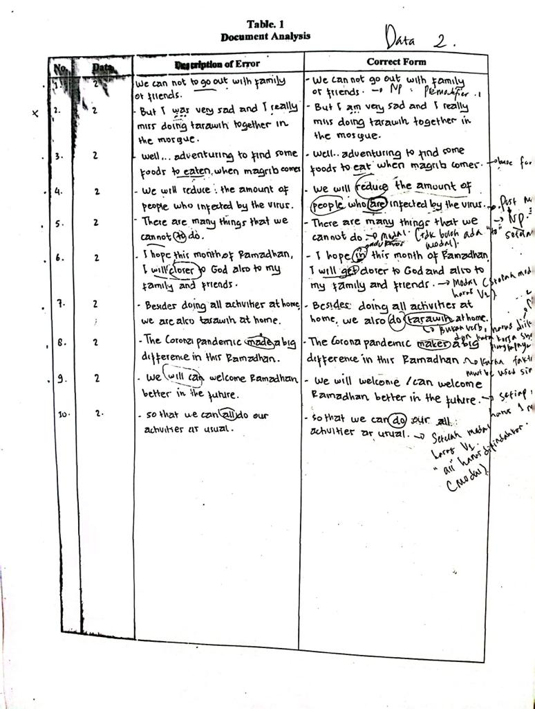

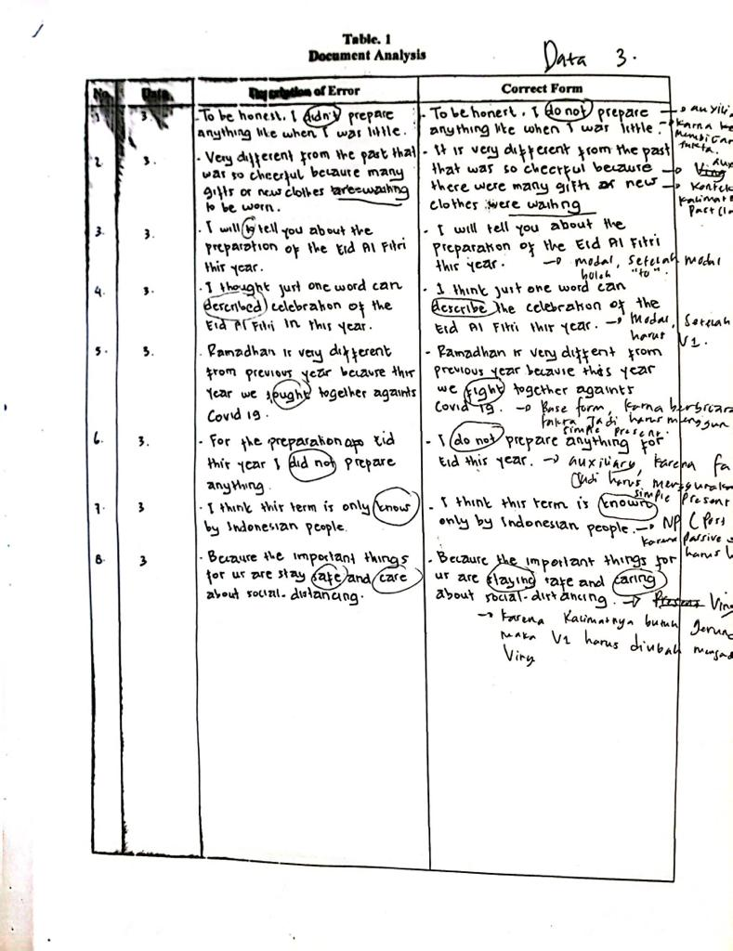

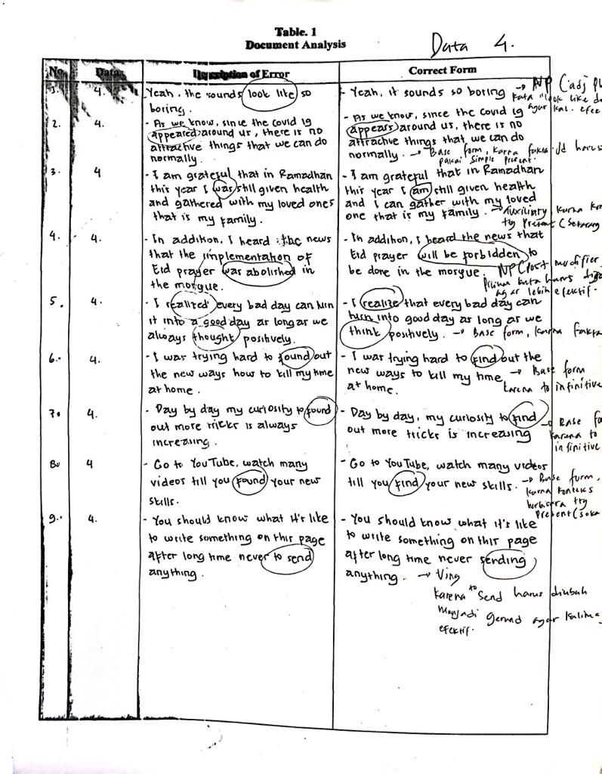

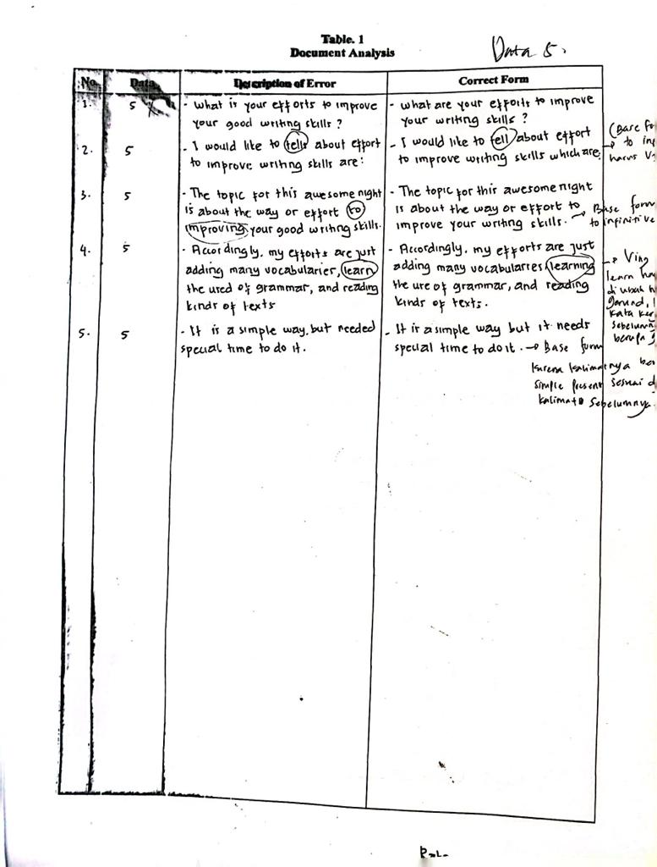

|  |  |  |  |  |  |  |  |  |  |  |  |  |  |  |  |  |
| --- | --- | --- | --- | --- | --- | --- | --- | --- | --- | --- | --- | --- | --- | --- | --- | --- |
| **No** | **Data** | **Verb phrase** | | | | | | | | | | | | | **Description of errors** | **Correct form** |
| **premodifier** | | | **verb** | | | | | | | **Post modifier** | | |
| Noun phrase | Adjective  phrase | Adveb  phrase | Base  form | modal | aux | ing | past | participle | | Noun  phrase | Adjective phrase | Adverb  phrase |
| present | past |
| **1.** | I ***do*** a lot of activities at home  (Fitri sarmawanti, “how’s your experience  about tarawih”) |  |  |  | √ |  |  |  |  |  |  |  |  |  | Because the previuos paragraph uses “past form” as the tense,the next paragraph must should be written in the past. | I **did** a lot of activities at home. |
| 2. | I ***making*** food to break the fast  (Fitri sarmawanti, “how’s your experience  about  tarawih”) |  |  |  |  |  |  |  |  | √ |  |  |  |  | Because the previous paragraph uses “past form” as the tense, the next paragraph should be written in the past form of simple past. | I **made** food for breaking fast |
| 3. | Just *doing* online class  (Fitri sarmawanti, “how’s your experience  about  tarawih”) |  |  |  | √ |  |  |  |  |  |  |  |  |  | Because the previous paragraph uses “past form” as the tense, the next paragraph should be written in the past form of simple past. | **Did** online class |
| 4 | Sometimes I *feel* bored  (Fitri sarmawanti, “how’s your experience  about  tarawih”) |  |  |  | √ |  |  |  |  |  |  |  |  |  | Because the previous paragraph uses “past form” as the tense, the next paragraph should be written in the past form of simple past. | Sometimes I **felt** bored |
| 5. | When I was a child, I went to mosque to sholat tarawih with my friends on my own age(ozy aqu ibonesta  “how’s your experience  about  tarawih”) |  |  |  |  |  |  |  |  |  |  |  |  |  | The correct from needs to added verb “do”. The word “sholat” is a noun that is way it should be added verb “do”. | When I was a child, I went to the mosque to do sholat tarawih with my friends on my own age |
| 6. | I mean the time *to took* several signature |  |  |  |  |  |  |  |  |  |  |  |  |  | The word “to took” has indicated to infinitive, that is way it should be changed into base form of the verb. | I mean the time **to take** several signatures. |
| 7 | When sholat tarawih *had* done, the time ***had been coming*.**  (ozy aqu ibonesta  “how’s your experience  about  tarawih”) |  |  |  |  |  |  |  |  |  |  |  |  |  | Because the previuos sentences use “past form” the next sentences should be written in the form of simple past tense, therefore the auxiliaries “had” and had been should be change in the auxiliaries of simple past | When sholat tarawih **was** done, the time **came** |
| 8. | We made a deal again *to played* the “mercon”  (ozy aqu ibonesta  “how’s your experience  about  tarawih”) |  |  |  |  |  |  |  |  |  |  | √ |  |  | The verb uses in “to invinitiveis verb 1 (base form), the word “played” should br change into “play”. | We made a deal **to play** the “mercon”. |
| 9. | I’*m* following the *government* instructions  (ozy aqu ibonesta  “how’s your experience  about  tarawih”) |  |  |  |  |  |  |  |  | √ |  | √ |  |  | The previous paragraph uses “past form” the next paragraph should be written in form whether it is simple past tense/past continuous. | I **was** following the **government’**s instructions. |
| 10 | I never *go* to mosque to do sholat tarawih together  (ozy aqu ibonesta  “how’s your experience  about  tarawih”) |  |  |  |  |  |  |  |  |  |  |  |  |  | Because the previous paragraph uses “past form” as the tense, the next paragraph should be written in the past form of simple past. | I never **went** to mosque to do sholat tarawih together. |
| 11. | The first time I *had had* my prayer as a child  (Dela astina “how’s your experience  about  tarawi  h”) |  |  |  |  |  |  |  |  |  |  |  |  |  | Because the text is used “simple past” the auxiliary “had” should br eliminated.. the sentence only needs “v2” after the subject. | The first time **I had** my prayer as a child. |
| 12. | May god *protec*t us all  (Dela astina “how’s your experience  about  tarawi  h”) |  |  |  | √ |  |  |  |  |  |  |  |  |  | The verb should be added “s”, it is because the sentence uses the third singular person as the subject. | May god **protects** us all. |
| 13. | We were assigned to worship in congregation  (Eka septiawati “how’s your experience  about  tarawih” |  |  |  |  |  | √ |  |  |  |  |  |  |  | Because the previous sentences uses “present tense” as the tense, the next sentences should be written in the form of simple past tense | We **are** assigned to worship in congregation. |
| 14. | After the prayer was over, we met the cleric to sign our book  Eka septiawati “how’s your experience  about  tarawi h”) |  |  |  | √ |  | √ |  |  |  |  |  |  |  | Because the previous sentences uses “present tense” as the tense, the next sentences should be written in the form of simple past tense and the verb met becomes “meet” (basic form) | After the prayer **is** over we **meet** the cleric to sign our book. |
| 15 | I *cannot* do it in the mosque.  (astute itsuwa “how’s your experience  about  tarawi h”) |  |  |  |  | **√** |  |  |  |  |  |  |  |  | As the contex of the sentence was happened in the past, so the modal sould be written in the form of simple past | I **could not** do it in the mosque |
| 16. | We *have to* follow the advice.  (fitri darwanti. “how’s your experience  about  tarawi h”) |  |  |  |  |  | **√** |  |  |  |  |  |  |  | The correct form of the auxiliary “have to” need to be changed into past form “had to” | We **had to** follow the advice |
| 17. | This *will not* break our spirit to worship.  (fitri darwanti. “how’s your experience  about  tarawi h”) |  |  |  |  | **√** |  |  |  |  |  |  |  |  | Relating to the previous sentence, the modal of “will” should be change into past form “would” | This **would not** break our spirit to worship |
| 18. | We *can* still do at home.  (fitri darwanti. “how’s your experience  about  tarawi h”) |  |  |  |  | **√** |  |  |  |  |  |  |  |  | The correct form of modal “can” should be changed into past form “could” | We **could** still do it at home |
| 19. | My father and my sister *are going* overseas. (fitri darwanti. “how’s your experience  about  tarawi h”) |  |  |  |  |  | **√** |  |  |  |  |  |  |  | Relating to the previous sentences uses “past tense” the next sentence should be | My father and my sister **went** overseas |
| 20 | When the isya’ time came, one of us had *to* adzan  (alan irawan “how’s your experience  about  tarawi h”) |  |  |  |  |  |  |  |  |  |  |  |  |  | because the sentence uses “to infinitive”, therefore, it should be added base form at the verb after “to” | When the isya’ time came, one of us had **to do** adzan |
| 21 | Before we went to home, we did the sarung *fight*  *(alan irawan* “how’s your experience  about  tarawi h”) |  |  |  |  |  |  |  |  |  |  |  |  |  | the correct form should br changed into gerund, it is because the noun ohrase needs a gerund from the verb “fight” | Before we went to home, we did the sarung **fighting** |
| 22. | But this year I have *to* tarawih prayer in my home  (msy apriliya hafizanti “how’s your experience  about  tarawi h”) |  |  |  |  |  |  |  |  |  |  | **√** |  |  | The correct form needs to added preposition “at” after the verb or before the wo rd “home”. | But this year I have **to do** tarawih prayer in my home |
| 23 | We visited some *place.*  (mil san“how’s your experience  about  tarawi h”) |  |  |  |  |  |  |  |  |  |  | **√** |  |  | The correct form needs to add “s” in the word “place”, the word “some “ has indicated plural noun. | We visited some **places** |
| **24** | Our deeds received by allas subhanahuwata’ala  (kurnia sri “what’s your hope in the month of ramadhan in this year?) |  |  |  |  |  | **√** |  |  |  |  |  |  |  | The correct form have to add a “tobe”, the words “received by” has indicated that the sentences is “passive voice” | Our deeds **were** received by allah swt |
| 25. | We *cannot* to go out with family  (kurnia sri “what’s your hope in the month of ramadhan in this year?) |  |  |  |  | **√** |  |  |  |  |  |  |  |  | The correct form should be changed the modal “can”into “could”. | We **could not** go out with family |
| 26 | well.. adventuring to find some foods *to eaten* when megrim comes  (kurnia sri “what’s your hope in the month of ramadhan in this year?) |  |  | **√** |  |  |  |  |  |  |  |  |  |  | because the words “to eaten” are to infinitive so after “to” should be following by base form. | well.. adventuring to find some foods **to eat** when megrib comes |
| 27 | We can throuh al of activities  (kurnia sri “what’s your hope in the month of ramadhan in this year?) |  |  |  |  |  |  |  |  |  |  |  |  |  | The correct form should add “verb” after the modal. | We can **go** through **al activities** |
| 28 | I hope all of patients are affected by the virus corona.  (kurnia sri “what’s your hope in the month of ramadhan in this year?) |  |  |  |  |  |  |  |  |  |  |  |  |  | The cohrrect form needs to eliminate preposition “of” and tobe “are”. | I hope all patients affected by the corona virus |
| 29 | we will reduce the amount of people who infected by the virus  (bulan bintang “what’s your hope in the month of ramadhan in this year?) |  |  |  |  |  |  |  |  |  |  | **√** |  |  | brcause the sentences is passive form therefore it needs to be added tobe “are” | we will reduce the amount of people who **are** infected by the virus |
| 30 | We *throught* difficult time  (lisa solsa “what’s your hope in the month of ramadhan in this year?) |  |  |  |  |  |  |  |  |  |  |  |  |  | It the correct form need to add verb2. The word “throught” after subject has indicated that it is a “phrasal verb”. | We **went** throught a difficult time |
| 30 | We *should living* this ramadhan as best as we can.  (lisa solsa “what’s your hope in the month of ramadhan in this year?) |  |  |  | **√** |  |  |  |  |  |  |  |  |  | The word “living” should be changed into “live”. The modal “should” has indicated that the verb after modal is in the base form. | We **should live** this ramadhan as best as we can |
| 31 | there are many things that we cannot *to do.*  (novi agnes paramitha “what’s your hope in the month of ramadhan in this year?) |  |  |  |  | **√** |  |  |  |  |  |  |  |  | Because after modal should be followed by base form of the verb | there are many things that we can not **do** |
| 32 | I hope pandemic corona immediently ended  (novi agnes paramitha “what’s your hope in the month of ramadhan in this year?) |  |  |  |  |  |  |  |  |  |  | **√** |  |  | The correct form need to add “tobe” as the complement of participle verb “ended”. | I hope **corona pandemic to be immediately ended** |
| 33 | I will closer to god  (novi agnes paramitha “what’s your hope in the month of ramadhan in this year?) |  |  |  |  |  | **√** |  |  |  |  |  |  |  | The correct form have to add be after modal. The word “closer” has indicated that the sentence is nominal. | I will **be** closer to god |
| 34 | All of us can meet with ramadhan next year  (novi agnes paramitha “what’s your hope in the month of ramadhan in this year?) |  |  |  |  |  |  |  |  |  |  | **√** |  |  | (novi agnes paramitha “what’s your hope in the month of ramadhan in this year?) | (novi agnes paramitha “what’s your hope in the month of ramadhan in this year?) |
| 35 | beside doing all activities at home we are also tarawih at home  (sri manangkalu “what’s your hope in the month of ramadhan in this year?) |  |  |  | **√** |  |  |  |  |  |  |  |  |  | the correct form should be added base form of the verb. It is brcause the word “tarawih” make the sentence/verb phrase more effective. | Beside doing all activities at home we are also **do** tarawih at home |
| 36. | so that we can all do our activities as usual  (sri manangkalu “what’s your hope in the month of ramadhan in this year?). |  |  |  |  |  |  |  |  |  |  |  |  |  | The correct form should be “do”. It is because after modal should be v1. | So that we can **do** our all activities as usual. |
| 37 | the corona pandemic *made* a big difference in this ramadhan (lidya sarry “what’s your hope in the month of ramadhan in this year?). |  |  |  |  |  |  |  |  |  |  |  |  |  | Because the statement is a fact. Therefore the verb should be in a base form | The corona pandemic **makes** a big difference in this ramadhan |
| 38 | *I’ll* going to tell about my hope.  redi wardani “what’s your hope in the month of ramadhan in this year?). |  |  |  |  | **√** | **√** |  |  |  |  | **√** |  |  | The word “will” should be eliminated, tobe+Ving has indicated that the sentence no need modal. | **I am** going to tell **you** about my hope |
| 39 | may Allah always *blessing* and protect us |  |  |  |  | **√** |  |  |  |  |  | **√** |  |  | The words “may allah” have indicated that verb should be written in the base form | may Allah always **bless**and protect us |
| 40 | so all muslim enjoyed this ramadhan without terror from covid-19.  mhedia oktavia “what’s your hope in the month of ramadhan in this year?). |  |  |  | **√** | **√** |  |  |  |  |  | **√** |  |  | The correct form should add modal “can” to make the meaning of the sentence more effective | So all muslim **can** **enjoy** this **ramadhan** without **the terror o**f covid-19 |
| 41 | we *will can* welcome ramadhan better in the future  (bimantara “what’s your hope in the month of ramadhan in this year?). |  |  |  |  | **√** |  |  |  |  |  |  |  |  | The correct form should be eliminated the modal “can” the two modals can not be written in one sentence. | we **will** welcome ramadhan better in the future |
| 42 | the beautiful and holy month *was* coming bringing so much happiness.  roni z saputra “how’s your preparation ahead of the eid al fitr in this year?) |  |  |  |  |  | **√** |  |  |  |  | **√** |  |  | the sentence is a fact, therefore it should be change into present, and the word “bringing” have to be changed because it is not effective egough. | the beautiful and holy month **is** coming with **so** much happiness. |
| 43 | I will tell about my preparation before eid.  (eka septiawati “how’s your preparation ahead of the eid al fitr in this year?) |  |  |  |  | **√** |  |  |  |  |  | **√** |  |  | the sentence needs an object to complete the sentence | I will tell **you** about my preparation before eid |
| 44 | to be honest, I *didn’t* prepare anything like when I was little.  (eka septiawati “how’s your preparation ahead of the eid al fitr in this year?) |  |  |  |  |  | **√** |  |  |  |  |  |  |  | It is because the statement is a fast, so the sentences should use simple present and the auxiliary used is “do not”. | To be honest, I do not prepare anything like when i was little. |
| 45 | very different from the past that was so cheerful because many gifts of new clothe *are* waiting to be worn.  eka septiawati “how’s your preparation ahead of the eid al fitr in this year?) |  |  |  |  |  | √ |  |  |  |  |  |  |  | the context of the sentence is past event, therefore the tense should changed into past. | vert different from the past that was so cheerful because **there were** many gifts of new clothe **were** waiting |
| 46 | I *will to* tell you about the preparation *of* the eid al fitr this year.  (arab, “how’s your preparation ahead of the eid al fitr in this year?) |  |  |  |  | **√** |  |  |  |  |  | **√** |  |  | the preposition “of” should be changed into “for” to make the meaning of the sentence becomes more effective | I *will* tell you about the preparation *for* the eid al fitr this year |
| 47 | I will tell about my preparation before the eid  (yeni rahayu, “how’s your preparation ahead of the eid al fitr in this year?) |  |  |  |  |  |  |  |  |  |  | **√** |  |  | the sentence needs an object to complete the sentence | I will tell **you** about my preparation before the eid |
| 48 | I thought just one of word *can described* celebration of the eid al fitr *in this year,*  (bayu segara, “how’s your preparation ahead of the eid al fitr in this year?) |  |  |  | **√** | **√** |  |  |  |  |  | **√** |  |  | The correct form needs to change verb into base form. It is because after modal should use verb one. | I thought just one of word **could describ**e the described celebration of the eid al **fitr this year,** |
| 49 | I’m not really care about that.  (bayu segara, “how’s your preparation ahead of the eid al fitr in this year?) |  |  |  |  |  | **√** |  |  |  |  |  |  |  | The correct form of the sentence should use auxiliary “ do not” for the negative form, it is because the sentence contains verb “care”. | I **do not** really care about that |
| 50 | I want to share with you about the preparation for the eid.  (ummiy muallimah, “how’s your preparation ahead of the eid al fitr in this year?) |  |  |  |  |  |  |  |  |  |  | **√** |  |  | to make the meaning of the sentence becomes more effective, the complement “with you” should be eliminated | I want to **share** about the preparation for the eid. |
| 51 | so that’s all I’m prepared for today.  (Mesis arianti “how’s your preparation ahead of the eid al fitr in this year?) |  |  |  |  |  | **√** |  |  |  |  |  |  |  | the sentence is active form, so it does not tobe “am” to complete the sentence | so that’s all I **prepared** for today |
| 52 | the market began *to crowded* at night.  (ridho aini, “how’s your preparation ahead of the eid al fitr in this year?) |  |  |  |  |  |  |  |  |  |  |  | **√** |  | the correct form should be added “be” it is because the word “crowded” is an adjective. | The market began **to be crowded** at night |
| 53 | I still have someone who always suportme.  (risky saputri, “how’s your preparation ahead of the eid al fitr in this year?) |  |  |  | **√** |  |  |  |  |  |  |  |  |  | because the sentence use present tense, so it should use base form of the verb for the third singular subject | Istill have someone who always **supports** me |
| 54. | Ramdhan is very different from previous year because this year we *thought* together agants covid 19.  (rio satrio “how’s your preparation ahead of the eid al fitr in this year?) |  |  |  | **√** |  |  |  |  |  |  |  |  |  | The cotext of the sentence is present, so the verb should be changed into present | Ramadhan is very different from previous year because this year we **fight** together agants covid 19 |
| 55 | For the preparation of eid this year i did not prepare anything.  (rio satrio “how’s your preparation ahead of the eid al fitr in this year?) |  |  |  |  |  | **√** |  |  |  |  |  |  |  | The sentence is a fact, so the auxiliary should changed into present. | I do not prepare anything for eid this |
| 56 | I think this term is only *know* by indonesian people.  (Ulva arha, “how’s your preparation ahead of the eid al fitr in this year?) |  |  |  |  |  |  |  |  |  |  | **√** |  |  | Because the sentence is passive form, so the verb should be changed into verb 3. | I think this term is **known** by indonesian people |
| 57 | almost everybody *think* that we *can do* our tradition as previous year.  (Ulva arha, “how’s your preparation ahead of the eid al fitr in this year?) |  |  |  | **√** |  |  |  |  |  |  | **√** |  |  | the contet of the sentence is a part event, so it should be use past verb and modal as wewell | almost everybody **though**t that we **could not** do our tradition as previous year |
| 58 | because the important things of us are *stay* safe and *care* about social-distancing.  (Ulva arha, “how’s your preparation ahead of the eid al fitr in this year?) |  |  |  |  |  |  | **√** |  |  |  |  |  |  | because sentence need “gerund” so” v1 must be “v ing" | because the important things for us are **staying** safe and **caring** about social-distancing. |
| 59 | As we know, since the covid-19 *appeared* around us, there is no attractive things that we can do normally. (ozy aqu ibonesta, “how’s you experience during this year’s month of ramadhan”). |  |  |  | **√** |  |  |  |  |  |  |  |  |  | Because the sentence is a fact, so the verb should be changed into present/ base form. | As we know, since the covid 19 **appears** around us, there is no attractive things that we can do normally. |
| 60 | yeah, the sounds *look like* so boring. (ozy aqu ibonesta, “how’s you experience during this year’s month of ramadhan”). |  |  | √ |  |  |  |  |  |  |  |  |  |  | Because the statement is a fact, therefore the verb should be in a base form | yeah, it sounds so boring |
| 61 | I can tell to my child later.  . (ozy aqu ibonesta, “how’s you experience during this year’s month of ramadhan”). |  |  |  |  |  |  |  |  |  |  | **√** |  |  | the correct form should be deleted the preposition, it is because the verb 1neds the object | I can tell **my child** later |
| 62 | I *can’t do* activities likes previous ramadhan.  (selpi arwenti, “how’s you experience during this year’s month of ramadhan”). |  |  |  |  | **√** |  |  |  |  |  |  |  | **√** | the correct form should change modal into past and the word “likes” into likes because the event was past and the word “like” is not the verb | I **could not** do activities **like** previous ramadhan |
| 63 | I am grateful that in ramadhan this year *I was* still given health and *gathered* with my loved *ones* that is my family.  (selpi arwenti, “how’s you experience during this year’s month of ramadhan”). |  |  |  |  |  | **√** |  |  |  |  |  |  |  | Because the context of the sentence is present, therefore auxiliary “was” should be changed into “am” | I am grateful that in ramadhan this year I am still given health **and I can gather** with my loved **one** that is my family. |
| 64 | I realized every bad day can *turn it into* a goo day as long as we always *thought* positively.  (Lydia hasana, “how’s you experience during this year’s month of ramadhan”). |  |  |  | **√** |  |  |  |  |  |  |  |  |  | . The sentence is a fact, therefore the tense should be changed into present. | I realize that every bad day can **turn into** good day as long as we **think** positively. |
| 65 | I was trying hard *to found* out the new ways how to kill my time at home.  (Lydia hasana, “how’s you experience during this year’s month of ramadhan”). |  |  |  | √ |  |  |  |  |  |  |  |  |  | Because the sentence uses “to infinitive”, so the verb should be changed into base form. | I was trying hard **to find** out the new ways to kill my time at home |
| **66** | Day by day my curiosity *to found* out more tricks is always increasing. (Lydia hasana, “how’s you experience during this year’s month of ramadhan”). |  |  |  | **√** |  |  |  |  |  |  |  |  |  | Because the sentence uses “to infinitive”, so the verb should be changed into base form. | Day by day, my curiosity **to find** out more tricks is increasing. |
| **67** | Go to youtube , watch many videos till you *found* your new skills.  (Lydia hasana, “how’s you experience during this year’s month of ramadhan”). |  |  |  | √ |  |  |  |  |  |  |  |  |  | Because the context of the sentence is present, so the verb should be changed into base form. | Go to youtube, watch many videos till you **find** your new skill |
| **68** | this ramadhan sometimes *make* me happy and exhausted.  “how’s you experience during this year’s month of ramadhan”). |  |  |  | √ |  |  |  |  |  |  |  |  |  | the correct form should change best form of the verb into past form, it is because the event happened in the past | this ramadhan sometimes **made** me happy and exhausted. |
| **69** | You should know what it’s like to write something on this page after long time never *to send* anythi  ng.  (silvi dayang sari, “how’s you experience during this year’s month of ramadhan”). |  |  |  |  |  |  | √ |  |  |  |  |  |  | The words “to send” should be replaced by gerund “sending” to make the meaning of the sentence more effective. | You should know what it’s like to write something on this page after long time never **sending** anything |
| **70** | I would like *to tells* about effort to improve writing skills.  (ulva arha“what is your effort to improve your good writing skills?) |  |  |  | √ |  |  |  |  |  |  | **√** |  |  | The correct form should change the verb “tells” into “tell” it is because to infinitive should use verb 1. | I would like **to tell** about effort to improve writing skills which are |
| **71** | The topic for this awesome night is about the way or effort *to improving* your good writing skill.  (ozy aqu ibonesta “what is your effort to improve your good writing skills?) |  |  |  | √ |  |  |  |  |  |  |  |  |  | the correct form should change the verb “improving” into “improve” it is because to infinitive should use verb 1. | The topic for this awesome night is about the way or effort **to improve** your writing skills |
| **72** | they are consisting on vocabulary aspect, grammatical aspect, and reading aspect.  (ozy aqu ibonesta “what is your effort to improve your good writing skills?) |  |  |  | √ |  |  |  |  |  |  | √ |  |  | the sentence is a fact, thus it needs the tense of simple present | they **consist** **of** vocabulary, grammatical, and reading **aspects** |
| **73** | Accordingly , my efforts are just adding many vocabularies, *learn* the used of grammar, and reading kinds of texts.  (ozy aqu ibonesta “what is your effort to improve your good writing skills?) |  |  |  |  |  |  | **√** |  |  |  |  |  |  | Because the sentence uses “and” as coordinate conjuctions, the noun phrase should be written in gerund form. | Accordingly, my efforts are just adding many vocabularries, **learning** the use of grammar, and reading kinds of text. |
| **74** | some people think that write a diary is activity that waste the time.  (risky putri “what is your effort to improve your good writing skills?) |  |  |  |  |  |  |  |  |  |  | √ |  |  | The correct form should change the verbs into gerund (v-ing), because to make it as a noun phrase it needs combination with gerund, not base form of verb. | some people think that **writing a diary** is **wasting time** |

**BIOGRAPHY**



Tiara was born in curup on 05 of augst 1998. She is daughter Mr.Bambang sutejo and Mrs.Marni . she has one brother and two sister. She finished her elementary school at SD 38 Curup Timur then, she continuous her study to junior high school at SMP 02 Curup Tengah, after that she carried to senior high school at SMA N 02 Curuo Timur. Next at 2017 she decided entering institute collage for Islamic studies (IAIN) Curup and chose English study program as her faculty.

1. Heaton as cited in ANGGRAENI, R. (2019). Students’ Ability To Construct Verb Phrase In Writing English Sentences.
2. A Case and Milne, Developing Writing Skil in English, Heilnimen Education Book,: London 1983. P. 57. In Thesis 2009 Wiwin Winiarti, Stain Curup
3. Graefen as cited in Piršl, D., Piršl, T., & Kesić, D. (2011). Writing skills at university level. *Short Scientific Paper on Sport Logia*, *7*(1), 69-72.
4. Jack C. Richard and W.A. Renandya. Methodology in Language Teaching: An Antology of Current Practice. Cambridge university Press. 2002. P. 303
5. . Radford, Andrew. 1988. Transformational Grammar (A first Course). Britain: Cambridge University Press.
6. H.Douglas Brown Brown. Dealing with Syntax as Approaches in Teaching. Addison longman Inc.2022.P.22
7. H.Douglas Brown Brown. Dealing with Syntax as Approaches in Teaching. Addison longman Inc.2022.P.22
8. Hoxa Rainz. The implication of feedback in error syntax in Teaching Grammar. Longman.inc. 2015.P.34
9. Prodi Tadris Bahasa Inggris. Borang tentang kegiatan HMPS dan Prodi. 2019
10. . Finocchiaro, Mary. 1974. English as a Second Language. New York: Regent Publishing Company
11. . Dumais, Wullur. 1988. Writing in English. Jakarta : Departemen Pendidikan dan Kebudayaan
12. . Lado, Robert. 1964. Language Teaching. Amerika: MC Grow Hill.
13. . Rise Axelrod and Charles R Cooper, The St. Martin’s Guide to Writing, (New York: St. Martin’s Press, Inc., 1983), p. 4.
14.
15. . Zulfani, Redyan. 2001. A study on Learning Writing Strategies of Good Language Learners. Universitas Bengkulu
16. . T. Linse, Caroline. 2005. *Practical English Language Teaching Young Learners*. New York: McGraw-Hill
17. . Oshima, Alice and Hogue, Ann. 1997. *Introduction to Academic Writing. Longman*
18. . Radford, Andrew. 1997. Syntax(A Minimalist Introduction). Britain: Cambridge University Press.
19. . Radford, Andrew. 1988. Transformational Grammar (A first Course). Britain: Cambridge University Press.
20. . Victoria, et.al. 2007. An Introduction to Language. USA: Thomson Wadsworth.
21. Verspoor M and Sauter K. 2009. English Sentence Analysis. Amsterdam. John Benjamins Publishing Company. Page 118-119
22. Delahunty, P and Garvey, J. 2010. The English Language from Sound to Sense. West Lafayette, Indiana : Parlor Press
23. . Radford, Andrew. 1988. Transformational Grammar (A first Course). Britain: Cambridge University Press.
24. . Ba‟dulu, M. (2008). English Syntax. Makassar: Badan Penerbit UNM.
25. Nelson and Greenbaum. 2002.An Introduction of English Grammar (second edition). Britain: Person Education Limited.
26. Palmer, F.R. 1981, *semantic*. Cambridge: cambridge university press.
27. Ibid. Carnie. P. 35
28. Fabb as cited in Setyaningsih, S., Haryanti, D., & Sutopo, A. (2013). *A Translation Shift Analysis On Verb And Verb Phrase Of The Avengers Movie And Its Subtitling* (Doctoral dissertation, Universitas Muhammadiyah Surakarta).
29. Morley, G. David. 2000. *Syntax in Functional Grammar (An Introduction to Lexicoggrammar in Systemic Linguistic)*. New York: Continum
30. Miller , Jim. 2002. An Introduction to English Syntax. Endiburgh University Press Ltd.
31. ibid. P,99
32. Ibid. P 49
33. Nelson and grandbaum. 2002.An Introduction to English Grammar (*second edition*). Britain: Person Education Limited.
34. Tarigan as cited in Kahar

    , S. H. (2019). *An analysis of the cohesion and coherence of the students’essay writing at the seventh semester students of english education department in muhammadiyah university of makassar* (doctoral dissertation, universitas muhammadiyah makassar).
35. Ika Dirga Saril, Hermawati Syarif, “*An Analysis Of Compound Sentences In Students ‘Writing* (Advances In Social Science, Education and Humanities Research, volume 301, 2018), p. 344
36. James, C. (1998). *Errors In Language Learning And Use : Exploring Error Analysis*. New York: Logman
37. Vacide Erdogan. 2005. *Contribution Of Erorr Analysis To Foreign Language Teaching*. P.263
38. Lexy J. Moleong. *Metode Penelitian Kualitatif*. (Bandung: Remaja Rosdakarya, 2011), Hal. 6
39. Sukardi. Metodelogi Penelitian Pendidikan. (Jakarta: Bumi Aksara, 2004), P. 157
40. Cresswell. Research Methodoogy in Educational Perpestives. Longman Press. 2021.P.34
41. David Wilkinson and Peter Birmigham, Op.Cit. P.116.
42. Ibid. P 120-122
43. Miles, M. B., Huberman, A. M., & Saldana, J. (1994). Qualitative Data Analysis: A Methods Sourcebook (Third). SAGE Publications.
44. Fabb as cited in Setyaningsih, S., Haryanti, D., & Sutopo, A. (2013). *A Translation Shift Analysis On Verb And Verb Phrase Of The Avengers Movie And Its Subtitling* (Doctoral dissertation, Universitas Muhammadiyah Surakarta).
45. Nelson and grandbaum. 2002.An Introduction to English Grammar (*second edition*). Britain: Person Education Limited